

ECE691 Project

Integrated Modeling, Identification, and Control of Thermal and Mechanical Dynamics using Educational Control Platforms

David C. Johnson

Advisors: Dr. Lu, Dr. Imtiaz
Faculty Reviewer: Dr. Malinowski

Department of Electrical and Computer Engineering

APRIL 2026

TABLE OF CONTENTS

PART 1 - TCLab Temperature Control Modeling

1. Introduction ……………………………………………………………………. 4
Feedback Control System Review………………………………………………..4
The TCLab System Description………………………………………………….5
Open-Loop Modeling: Step Response Experiment………………………………9
PID Control Design………………………………………………………………11
Model Validation…………………………………………………………………12

2. Control Theory and Dynamic Modeling: Differential Equations Review…..7
Convert Physics into Control Form………………………………………………7
How experimental data “builds” the transfer function……………………………7
PID Information and Plot…………………………………………………………12

PART 2 – PID Control of the Quanser QUBE-Servo 2 System Description …..15

2.1. Interfacing ……………………………………………………………………15
Simulink Model
Data Plot
2.2.Filtering ….……………………………………………………………………18
Simulink Model
Data Plot
2.3. PID ……………………………………………………………………………21
Simulink Model
Data Plot
2.4. Stability ……………………………………………………………………….24
Simulink Model
Data Plot
2.5. Swing Up ……………………………………………………………………..27
Simulink Model
Data Plot
2.6. Conclusion ……………………………………………………………………41

Appendix …………………………………………………………………………..42
References

Abstract

Popular in the field of Electrical Engineering is the topic of Modern and Classic Control feedback systems characterized by the use of components that cause the system to literally self-correct itself around a targeted goal or condition. This report involves two case studies of control systems: First is a Temperature Control or Thermal system (slow, first-order dominant) system wherein a data set is produced within the TCLab © system before fitting the data to a model for scrutiny (typically ‘approximating’ a PID structure; the Second study consists of an Electromechanical servo (fast, low inertia, high bandwidth) Quanser Qube Servo2 system which utilizes an actual PID feedback control structure for the purpose of producing its own data and plot (via Simulink). This report will be a systematic and comprehensive disclosure of the setup and experiments involved within the course of this study.

1. Introduction (Outline)

Due to a happy accident (depending on perspectives involved) there was a technical difficulty with the Quanser Quber Servo 2. It fell due to gravity and it was out of commission for a few weeks. While that tragedy took place, it opened the door for the exploration of Control Systems via the exploration of the TCLab Temperature control system. Therefore this project has two parts: Part 1 pertaining to Control Systems and Temperature Measurements and Part 2 pertaining to the Pendulum arm of the Quanser Qube Servo 2 system. Both are outlined below.

The motivation for each pertained to gaining knowledge of how feedback systems regulate physical processes integrating both the Thermal System (TCLab) with its slow first-order dynamics and the Electromechanical System (Qube Servo 2) with its fast nonlinear dynamics and processing the data into a single report.

The TCLab © technology as an educational platform
- Used to illustrate modeling of a control system pertaining to temperature.
- The factors: convection, conduction, and radiation discussed
- Predict temperature behavior of the system given carefully timed input step signals. Block Diagram Shown.
Part1: TCLab-Temperature Control
- The TCLab System Description
- Open-Loop Modeling: Step Response Experiment
- Closed-Loop Modeling
- Model Validation
- Controller Design
- PID Control Design, Data, and Plots
- Conclusion
The Quanser Qube Servo2 as an educational platform
- Used here to illustrate modeling of a control system pertaining to the swinging behavior of a pendulum.
- PID control of the system and Stability of the System
- Control the behavior of the pendulum given input/output model
- Block diagram/Simulink Model.
Part 2: Quanser Qube Servo2
- Quanser Lab Description
- Interfacing/Filtering
- PID Control Design
- Stability
- Swing UP Energy Control Model
- PID Control Design, Data, and Plots
- Controller Design
PART 1 - TCLab Temperature Control Modeling

Feedback Control System Review

Closed Loop Feedback Control systems are essential in modern engineering applications where stability, robustness, and performance are required under uncertainty and disturbance.
Reference: The desired target value the system is trying to reach.
Error: The difference between the reference and the actual output.
Controller: The algorithm that computes the control action based on the error.
Plant: The physical system being controlled, whose behavior the controller influences.
Typically: r(t) → Controller → Plant → Sensor → Feedback
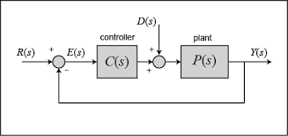
This project focuses on a temperature control problem implemented on a low-cost microcontroller platform. An Arduino-based system, interfaced through the TCLab environment, is used to collect thermal data, identify a dynamic model, and implement feedback control strategies. Mathematical modeling via differential equations and transfer functions provides insight into system dynamics, while experimental validation demonstrates how theory translates to practice.

The TCLab System Description
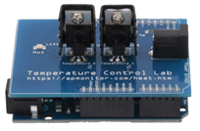
Goal: What Will Be Built?
The goal is to develop a thermal model of the TCLab for the purpose of demonstrating how to model a temperature control system. It will also identify system parameters from step‑response data and in the long run the control system will be used to design and tune a PID controller, the reason for this will become clear as the report develops. Ultimately, the process will involve validating the controller against real hardware. Finally, the procedure will involve comparing model predictions to measured data.
The TCLab consists of (1) an input: Heater power (PWM %), and (2) an output: Temperature (°C). It displays dynamics with Slow thermal response due to heat capacity and convection losses. The thermal systems are typically:
- Stable
- First-order dominant
- With time delay
Specifically, the Temperature Control Lab (TCLab) provides a practical platform for studying thermal system dynamics and classical control design. As mentioned, the system consists of a heater and temperature sensor, forming a single-input single-output (SISO) thermal process.
The goal of each experiment from Lab A to Lab G was to design, model, and demonstrate control of an Arduino-based temperature monitoring and control system using the Temperature Control Laboratory (TCLab) platform. The labs emphasize transfer-function modeling, parameter estimation, and feedback controller design. A first order-plus-dead-time (FOPDT) model is identified from experimental step-response data collected via an Arduino microcontroller with dual heaters and temperature sensors. Controller performance is evaluated using time-domain metrics and error criteria, including Integral Absolute Error (IAE). Experimental results are compared against theoretical predictions to assess model fidelity and control effectiveness.
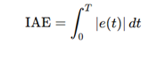
e(t)=r(t)−y(t) r(t): reference (setpoint)
y(t): system output
∣e(t)∣: absolute value of the error
T: total time of observation
Experimental results (a data set) are compared against theoretical predictions to assess model fidelity and control effectiveness.

Restating, the objective of this part of the project is to:
- Develop a mathematical model of the thermal system
- Identify system parameters experimentally
- Design and analyze PID control performance

2. Typical TCLab Modeling: Lab Data - One and Two Heater
:Open Loop Equation Development - Analysis
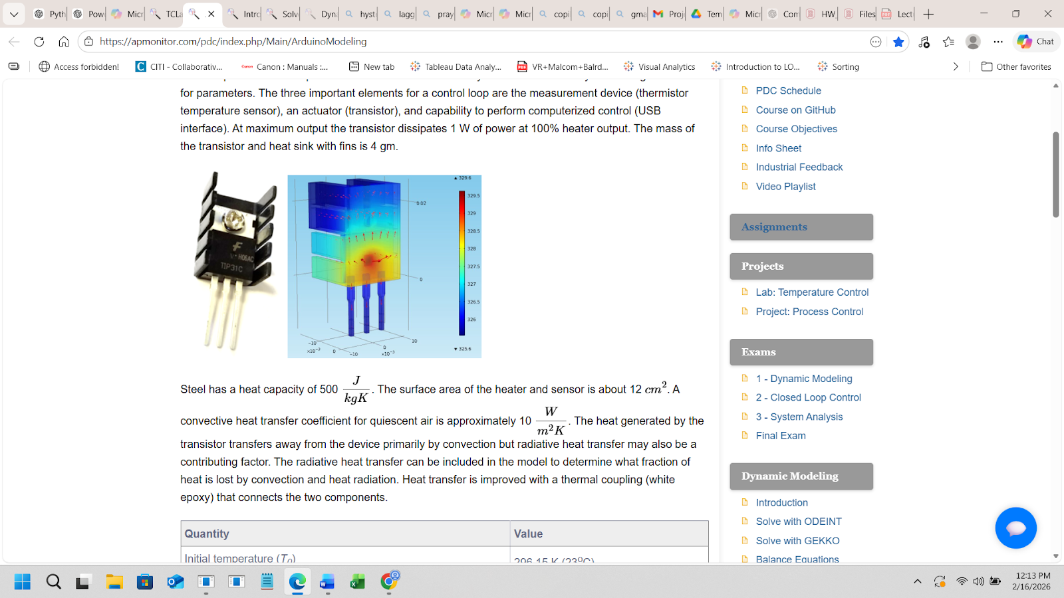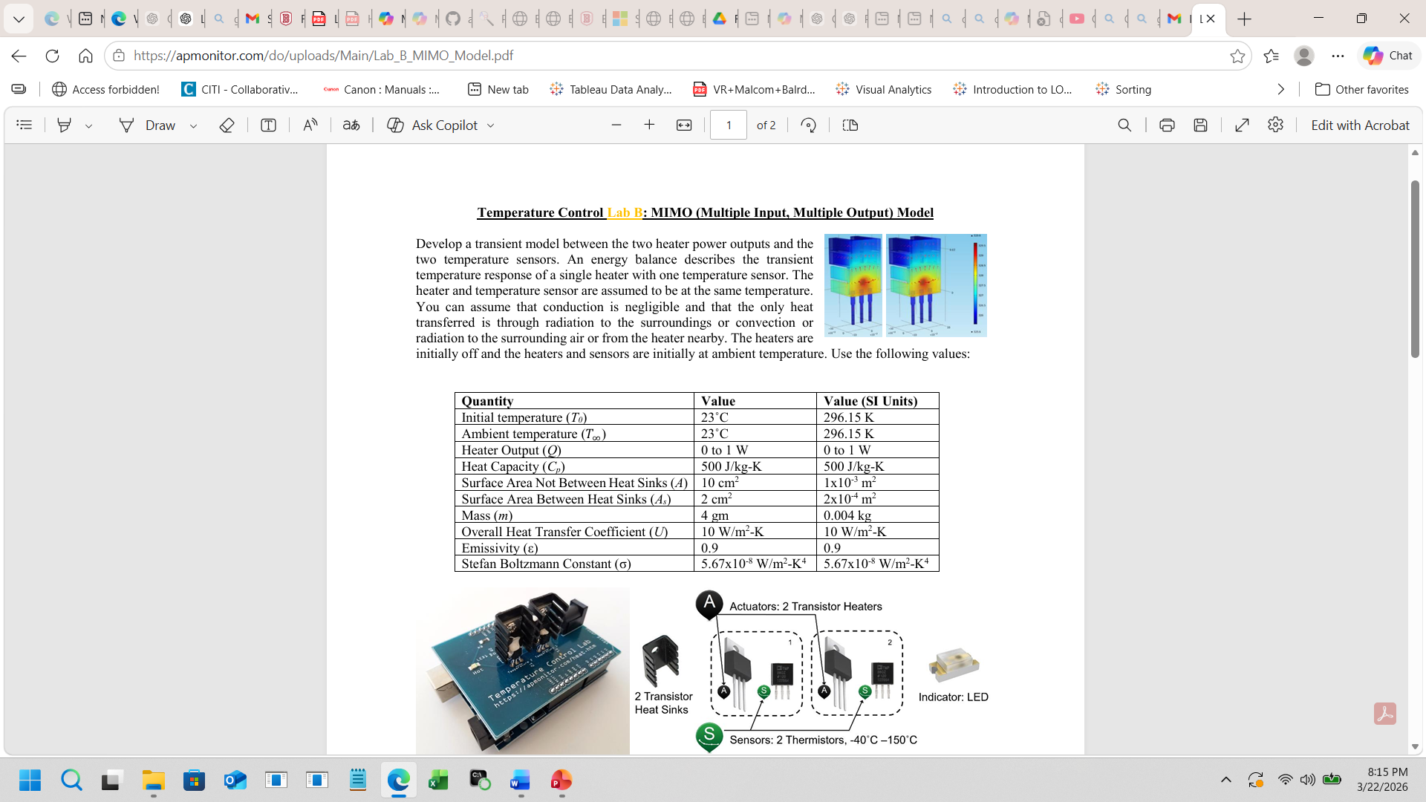

“Derive a nonlinear transient model and fit a linear first-order or second-order system. Compare model predictions to transient lab data.”
The governing energy balance equation given is:

One heater: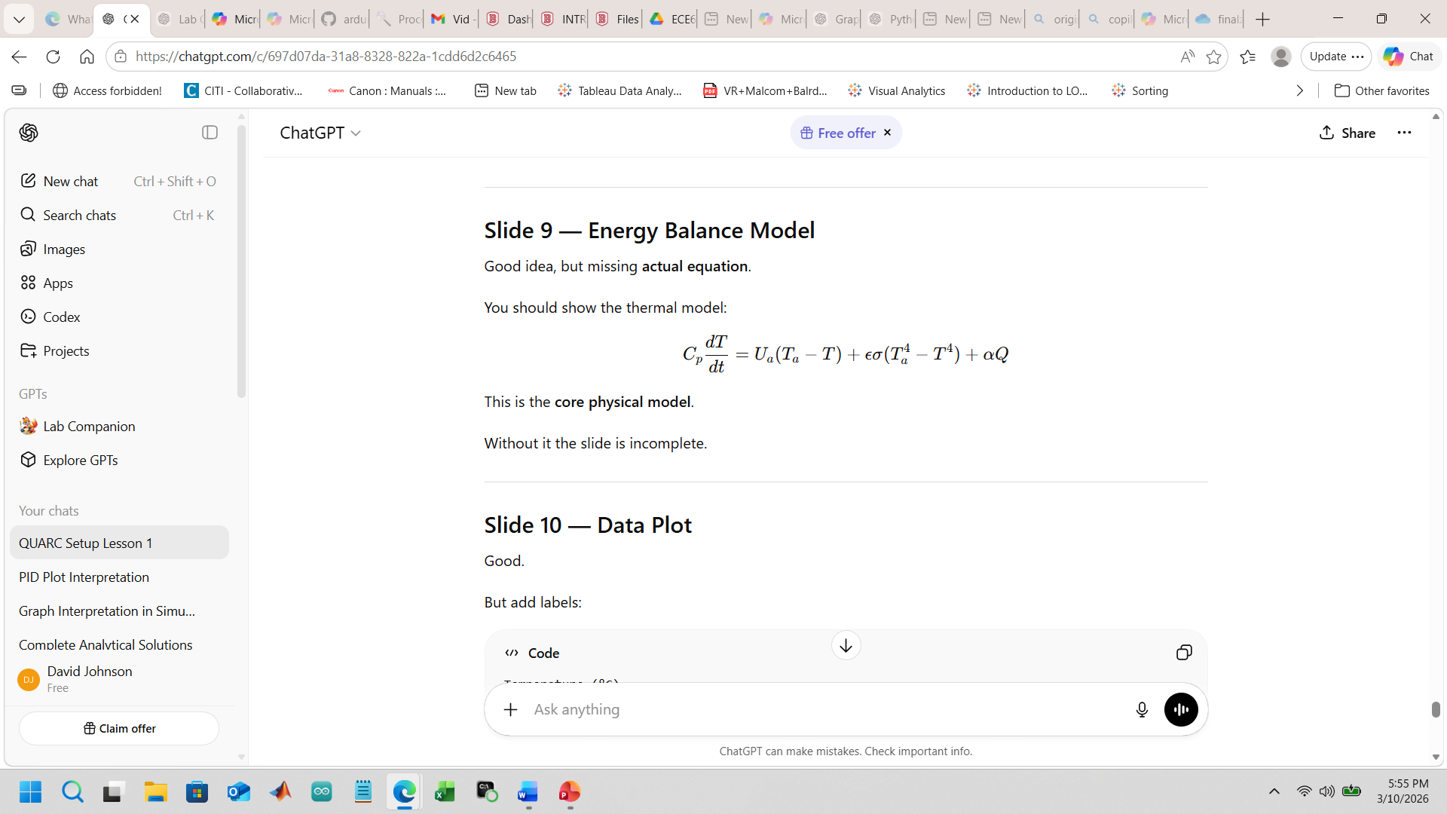
Total convection radiation heater
Two heater: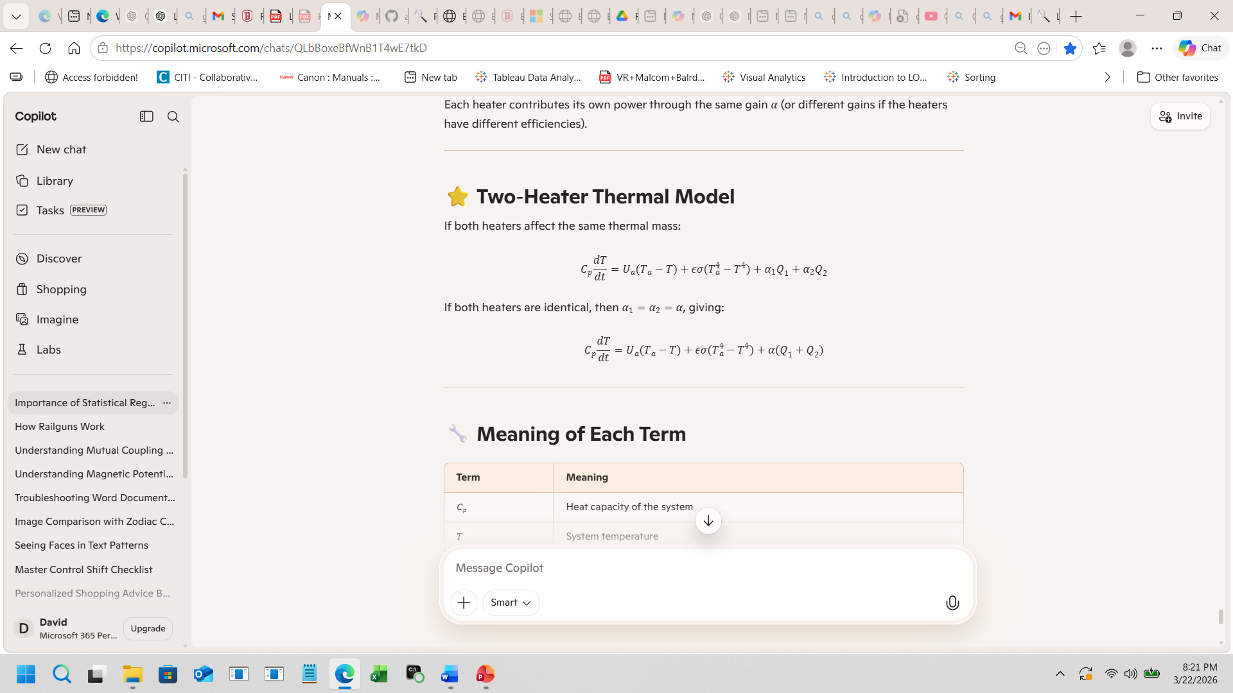
Total convection radiation heater1 & 2

Utilizing this information, linearize the energy‑balance equation around an operating point.
Steps:
- Choose a steady‑state temperature T₀ and heater input Q₀.
- Linearize the nonlinear ODE around that point.
- The radiation term becomes a linear slope:
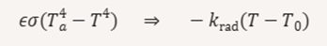
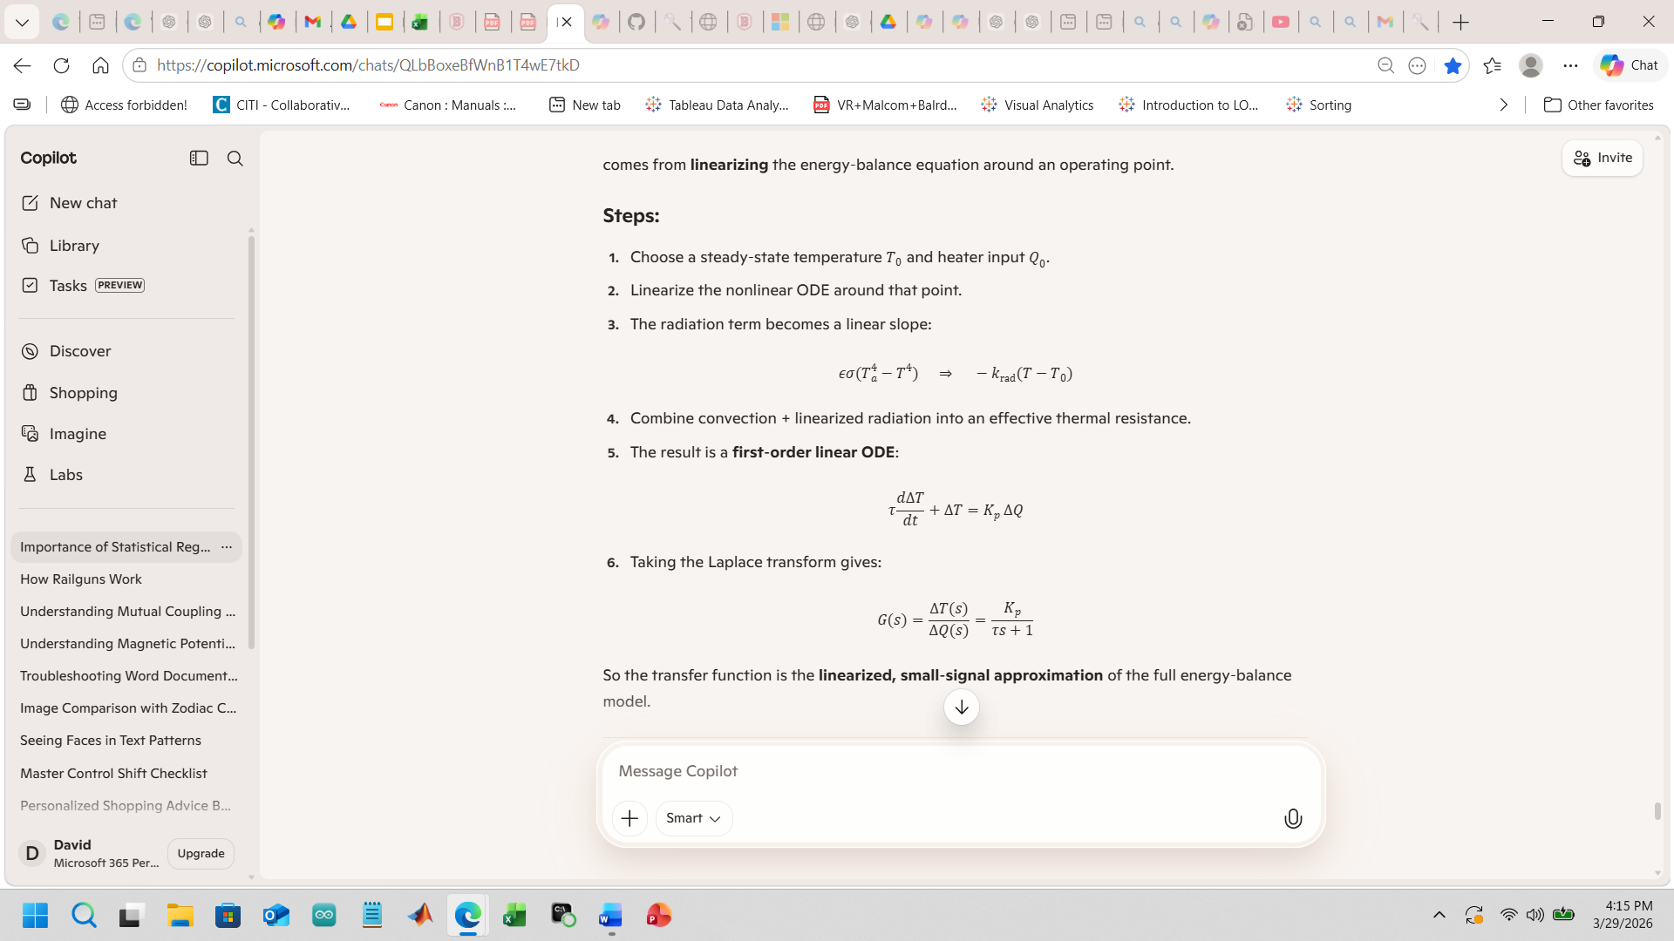

The objective at this point is to generate a step input and analyze the closed loop response of:

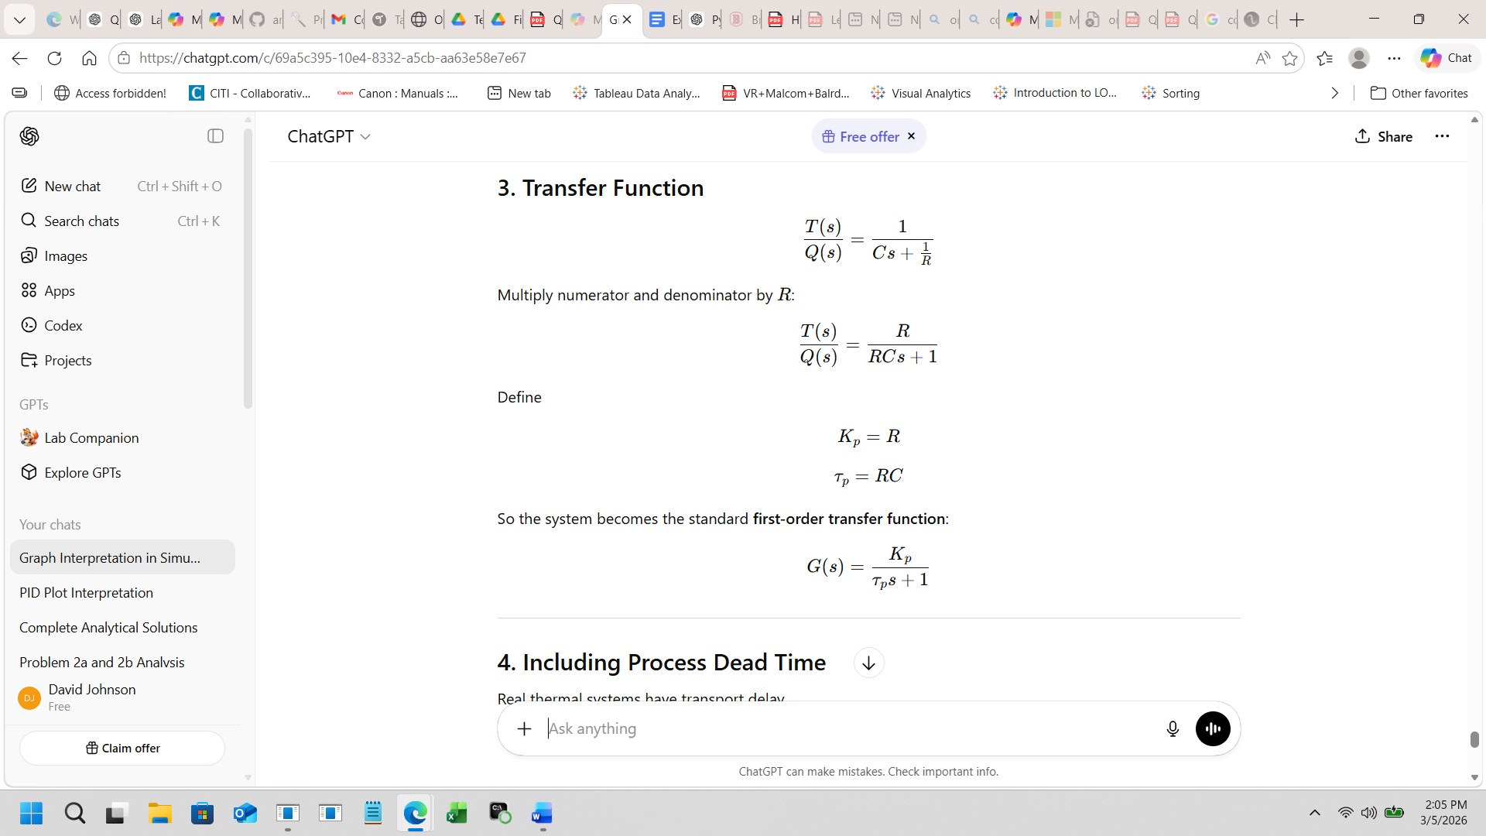
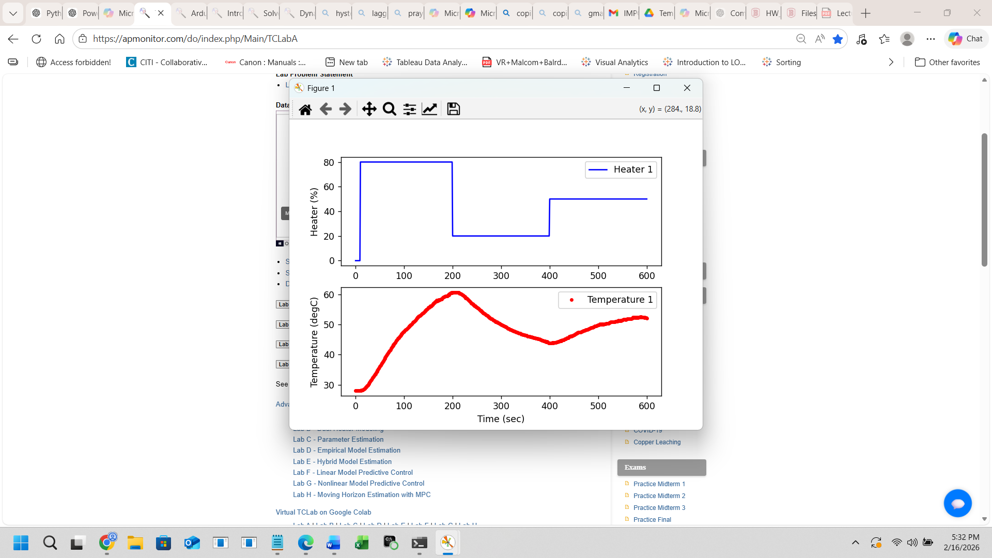
Open-Loop Modeling: Step Response Experiment
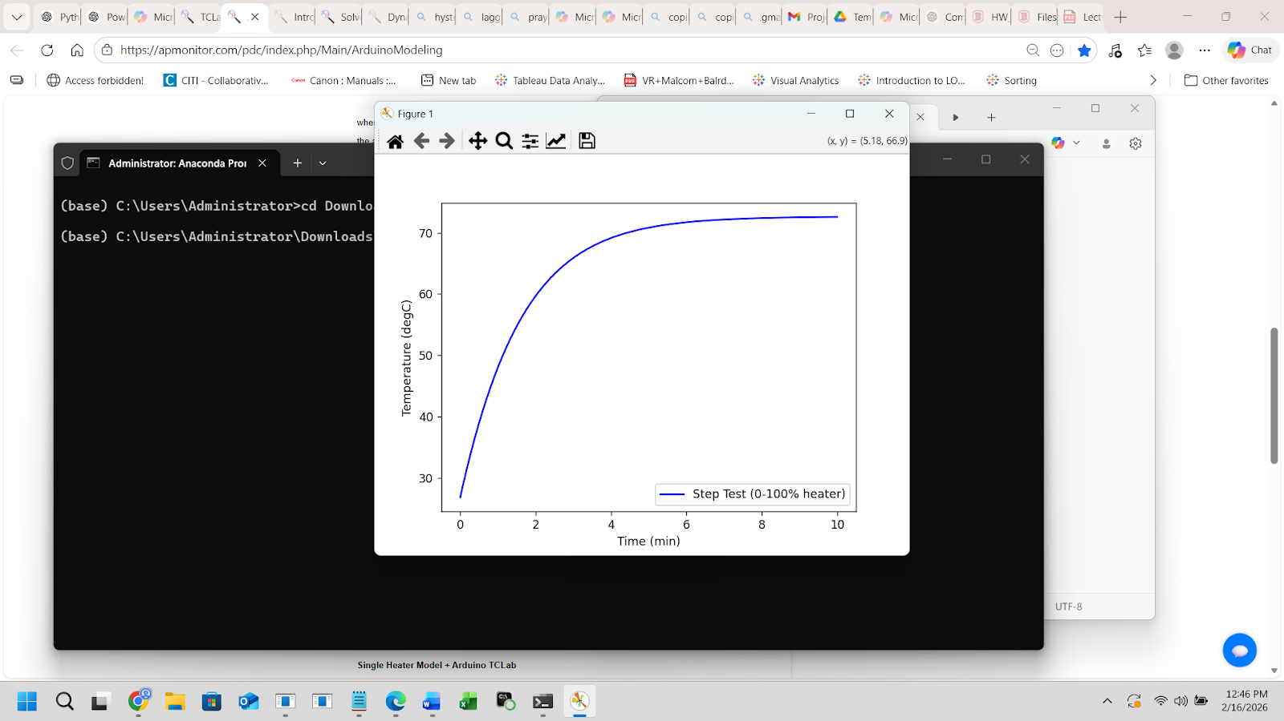
A step input in heater power was applied, and temperature response was recorded.
Observed characteristics:
- Slow rise
- No oscillation
- Exponential-like behaviorSteady-state gain identifiable.

Dealing with the Heater Slowly Rising in Temperature: Delay = Dead Time
There is a delay caused by the heater slowly rising in temperature: a first order-plus-dead-time (FOPDT) model is identified from experimental step-response data collected via an Arduino microcontroller with dual heaters and temperature sensors.
Where:
K_{p}(process gain): How much the output changes in steady state for a given change in input.
ͳ_{p}(time constant): How quickly the process responds, representing the speed of its natural dynamics.
θ_{p}(dead time): The delay before the process output begins responding to an input change.
.

Because Real Thermal systems have transport delay
(Dead Time) where in this case:

Kp is 1
Tau is 60 sec
Theta is 20 sec

Yielding the actual equations:

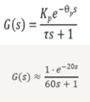

Now understanding the TCLab system, we collect step‑response data to characterize its dynamics using two models.
Why Two Models?
1) FOPDT: Simple, fast to tune, good for single‑heater control
2) Energy balance: Physics‑based, captures cross‑coupling, needed for two‑heater systems
3) Comparison goal: Evaluate accuracy vs. complexity
4) Other models like the Moving Horizon, 2nd Order Model, ARX (AutoRegressive) model, and
Neural Network were beyond scope of this presentation

Explaining the Heater Plots
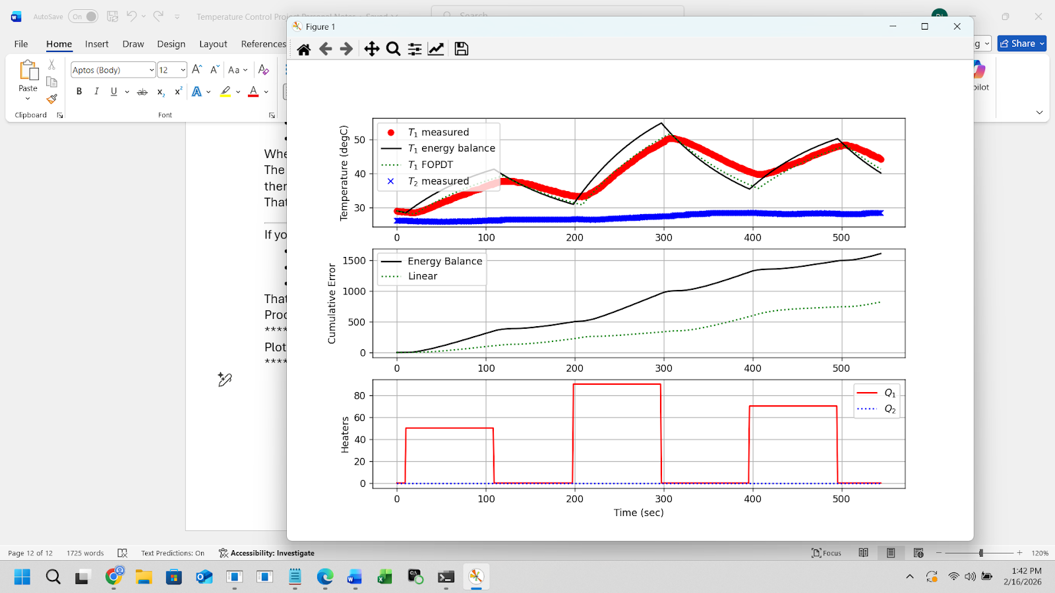
Panel 1) Measured and modeled temperature response for T₁ and T₂(flat). The plot compares the experimental temperature data (T₁ measured, T₂ measured) with two model predictions: the full energy‑balance model (--) and the first‑order‑plus‑dead‑time (FOPDT) approximation. Shows how well each model captures the heating dynamics under the applied heater inputs.

Panel 2) Cumulative error between measured temperatures and model predictions. The energy‑balance model exhibits lower accumulated error over time compared to the linear FOPDT model, indicating a more accurate representation of the system’s thermal behavior.

Panel 3) [below]Heater power inputs Q₁ and Q₂ (off) over time. These signals represent the applied heating profiles that drive the temperature dynamics shown in the upper panels.
Here it should be noted that with a validated model, we now design a PID controller to regulate temperature. But, why is a controller necessary?
1) Maintain temperature despite disturbances
2) Achieve fast rise time with minimal overshoot
3) Reject noise and ambient fluctuations
4) Track changing setpoints

PID Control Design Theory
The PID controller:
$C(s)=K_{p}+\frac{K_{i}}{s}+K_{d}s$
Control objectives:
- Minimize steady-state error
- Reduce rise time
- Avoid overshoot
- Maintain stability
Observations:
- $K_{p}$reduces rise time
- $K_{i}$eliminates steady-state error
- $K_{d}$reduces overshoot
Due to the slow nature of thermal systems, derivative action had limited impact
compared to electromechanical systems.
In addition to the factors spoken of above is the Control Law. This is the mathematical bridge between the physics of the thermal system (the energy‑balance equation) and the action of the PID controller (the voltage or heater power actually applied).
TCLab PID Block Diagram

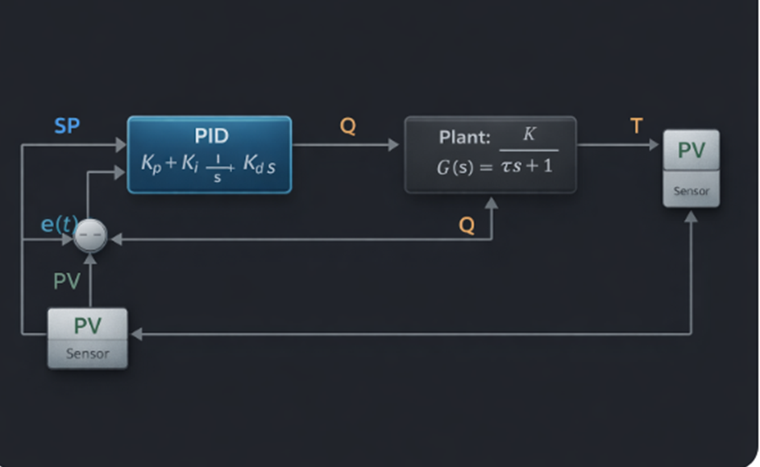
Here the PID controller is placed inside the full temperature control loop, showing how the error
drives the controller and how the plant and sensor feed temperature back.

Testing the controller on Real Hardware requires three things:
- Apply step changes in setpoint
- Record temperature and heater output
- Compare measured response to model predictions

Next will involve model validation.

Model Validation

For most of the labs A - G (with the exception of the PID lab) the identified model was simulated and compared to prerecorded experimental data. Agreement between model and measured response confirmed:
- Dominant first-order behavior
- Negligible higher-order dynamics
- Small but present time delay

PID Information and Plot

The following plot was achieved from the use of a Python program with a LIVE PID control board. The information about each panel is given below.
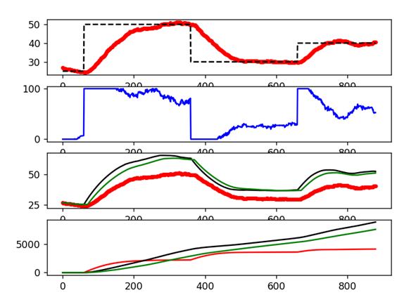

******************************************************************************
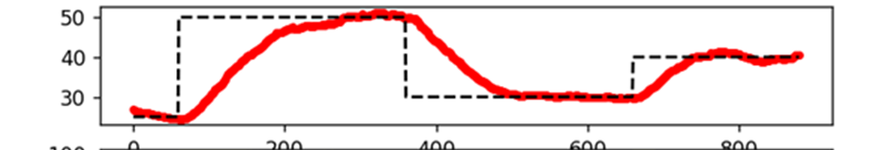
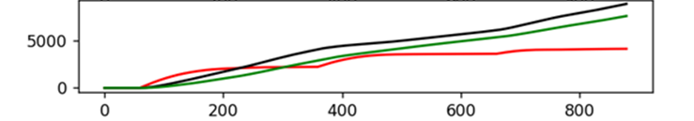
Panel 1 (above)
The red dots measured temperature T1 (real hardware), while the black dashed measured the Setpoint Tsp1. This reveals the closed-loop tracking performance.

- Step from 25 → 50 °C
- Then 50 → 30 °C
- Then 30 → 40 °C
- From the graph is shown:
- Strong rise
- Some overshoot near 50
- Smooth settling near 30 and 40
- This panel answers how ‘well is the PID tracking the setpoint?’
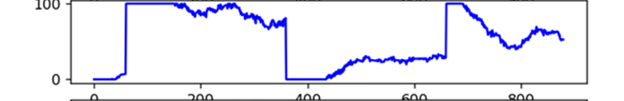

Panel 2 (above)
Heater 1 output (% power)
This is the controller effort.
You can see:
Large spike to ~100% during 50°C step
Drops to 0% during cooldown
Moderate output during 40°C step
This panel answers:
“What is the PID doing to achieve tracking?”
It also reveals:
Saturation at 100%
Integral windup prevention working (since it backs off cleanly)
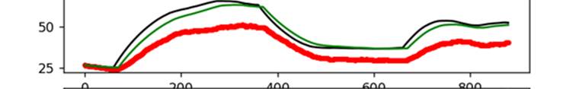

Panel 3 (above)
Red dots: Real measured T1
Black line: Energy balance model prediction (Tp) observe tracks shape fairly well
Green line: FOPDT model prediction (Tpl) observe both deviate slightly during large transients
This is the model validation plot.
It compares:
Physics-based nonlinear model
Simple first-order-plus-dead-time model
Actual plant
This panel answers:
“How good are my models?” and “Which model better captures the real heater dynamics?”

Panel 4 (above)
What it shows:
Red: Tracking error (controller performance)
Black: Energy balance model prediction error
Green: FOPDT model prediction error
This panel answers:
“Which performs better over time?”
Lower curve = better performance.
From the plot:
Red grows moderately → tracking error accumulation
Black and green show model mismatch accumulation
One model likely grows slower (better predictor)
This is effectively an integrated absolute error (IAE) metric.

TCLab PID Controller Summary

- Implemented using a Python program connected to a live temperature control board to evaluate closed-loop performance. The PID constant values were: kp=10, ki=0.2, kd=10

- The temperature setpoint was stepped from 25 °C to 50 °C, then to 30 °C, and finally to 40 °C while the system response was recorded. The measured temperature closely tracked the setpoint with a fast rise time, minor overshoot near the 50 °C step, and smooth settling during the later transitions, indicating stable controller tuning.

- The heater output plot shows the controller effort required to achieve this behavior, including a brief saturation near 100 % power during the large heating step and a drop to 0 % during cooldown, demonstrating effective integral windup protection.

- Model validation via comparing the real temperature response to predictions from an energy balance model and a first-order plus dead-time (FOPDT) model. Both models captured the general system behavior, though small deviations appeared during larger transients.

- Finally, error plots comparing tracking and model prediction errors provided an integrated view of performance over time, showing moderate tracking error growth and highlighting differences in predictive accuracy between the two models.
Part 1 TCLab Conclusions
- FOPDT model captures main dynamics; but, energy balance model is more accurate
- PID controller achieves stable tracking with minimal overshoot
- Real data matches model predictions closely
- TCLab provides a reliable platform for teaching modeling and control

PART 2 – PID Control of the Quanser QUBE-Servo 2 System
The Quanser QUBE-Servo 2 is a DC motor-driven rotary arm equipped with a high-resolution encoder.
System components:
- Input: Motor voltage (±10V)
- Output: Angular position (rad)
- Encoder resolution: 2048 counts/rev
- Fast electromechanical dynamics
Unlike TCLab, this system is:
- Fast
- Sensitive
- Quantized
- Noise-prone when differentiating

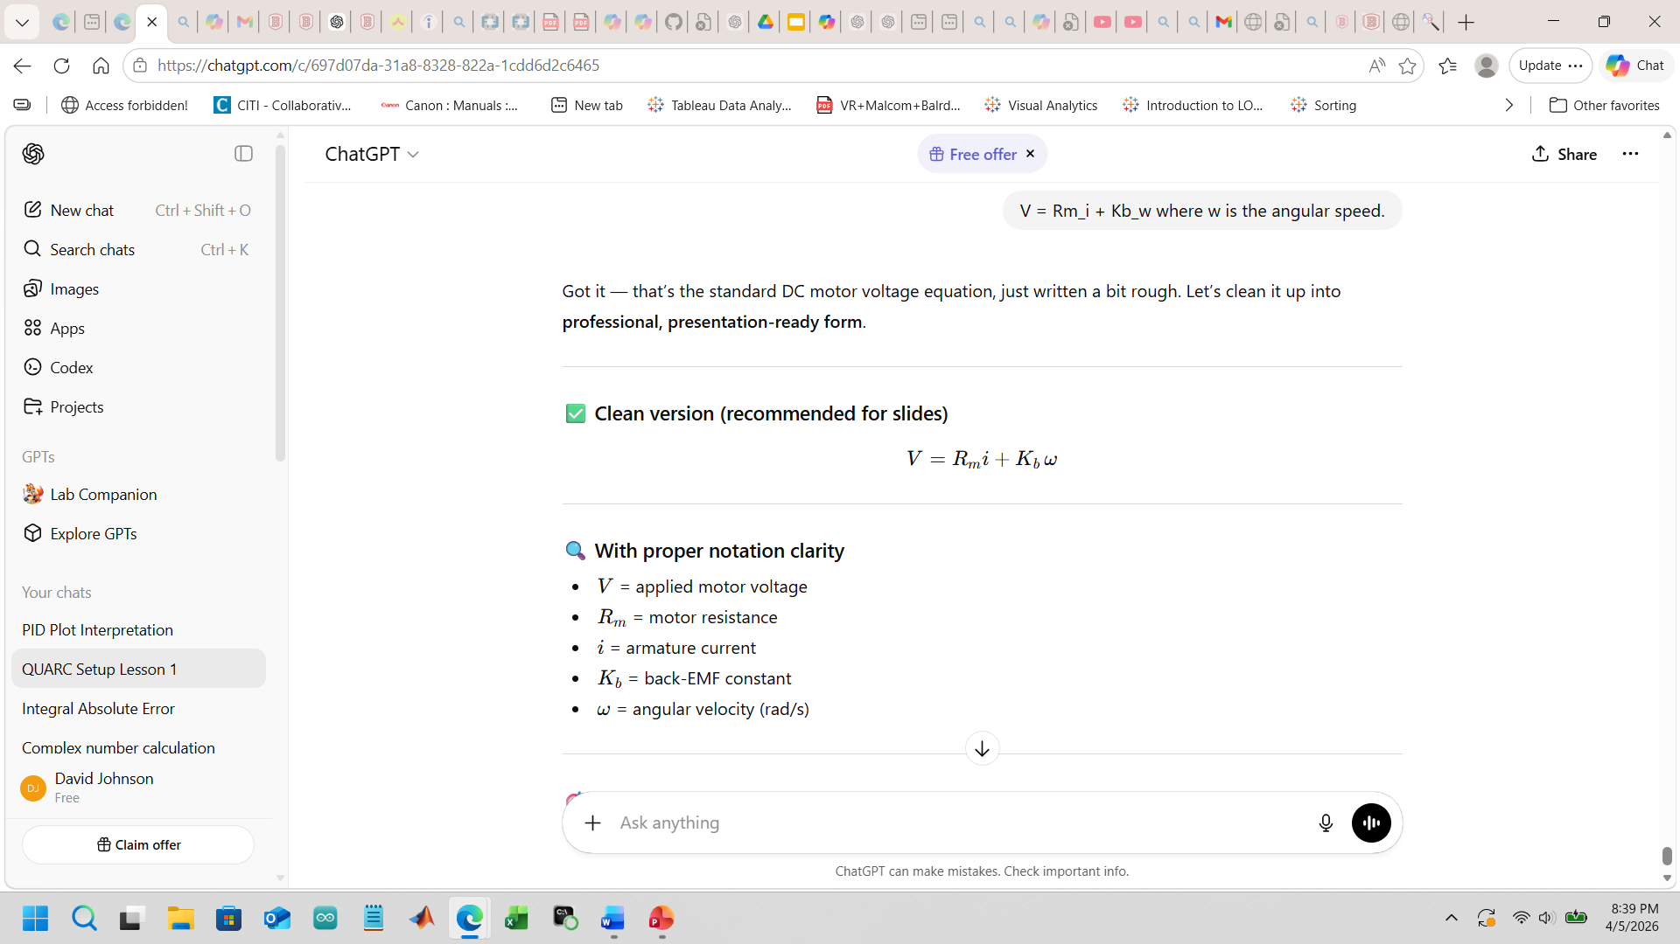
τ=K_{t}i

Above are two core physical laws that explain how the
QUBE‑Servo 2 converts electrical input (voltage) into mechanical motion (torque and angular acceleration).

1. Electrical Dynamics

This tells you:
- Part of the voltage drop is due to resistance
- Part is due to back‑EMF, which grows with speed
- The current i is what produces torque

2. Mechanical Dynamics
τ=K_{t}i
Jω˙+bω=τ
Combine them, and you get the full transfer function from voltage → angular velocity.

This part of the project, part 2, utilizes Simulink in order to facilitate four important models for manipulating the Quanser Qube and demonstrating its performance. The Simulink models are Calculus/Differential Equations based and the model is based on the implementation of math based components. There are, moreover, four important stages of development for making the Qube’s arm stand upright which is the goal of Part 2 of this project. These stages demonstrate (1) Interfacing,(2) Filtering ,(3 PID Controller) , and (4) Stability. Each stage builds upon the previous stage towards the final goal of Swing up energy injection.

What Hardware‑in‑the‑Loop (HIL) Means for Simulink

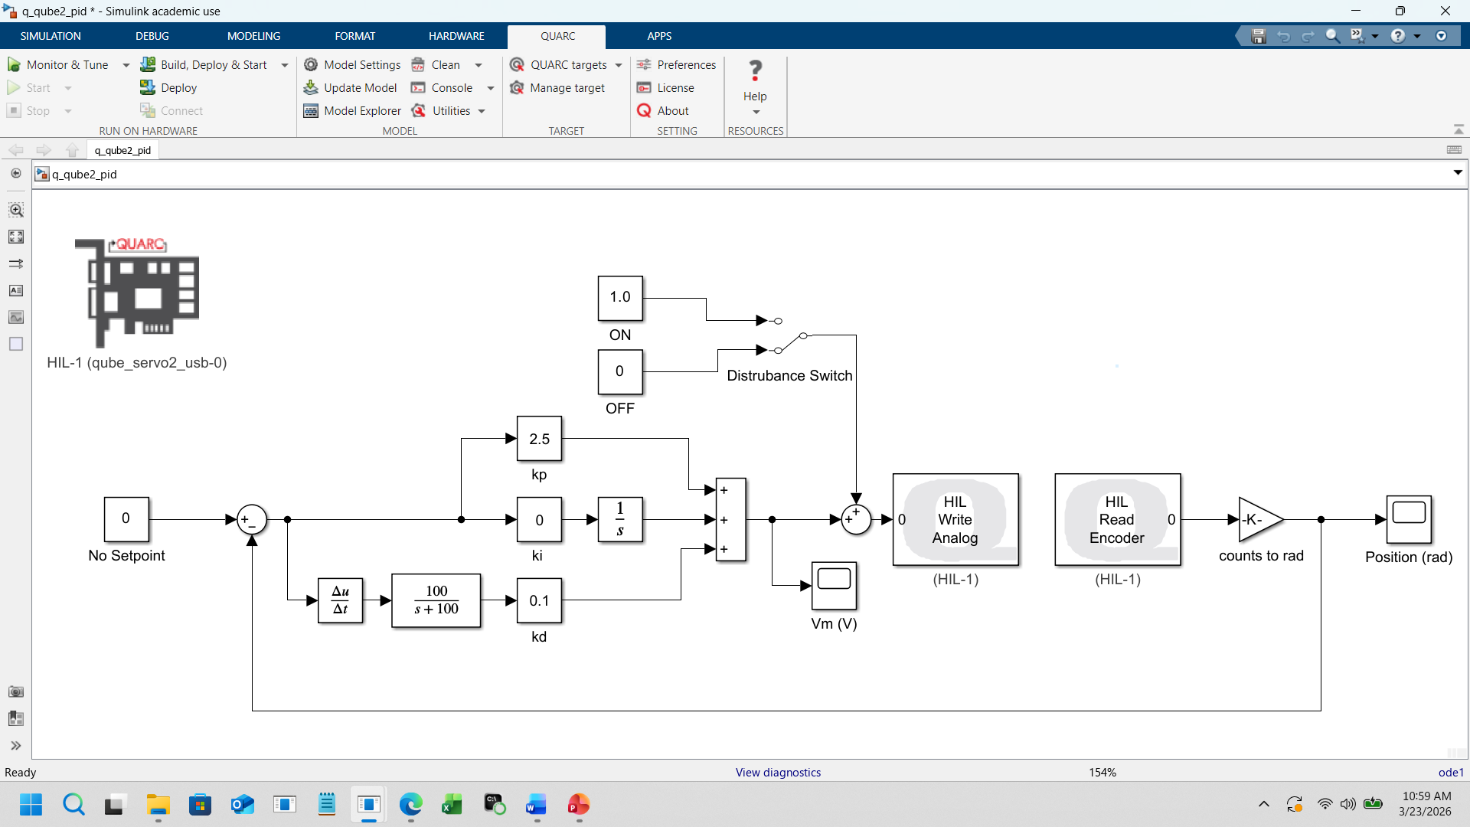

Hardware‑in‑the‑Loop (HIL) is when a Simulink model runs in real time and exchanges signals directly with the physical QUBE hardware. Instead of simulating the plant, Simulink “talks” to the actual motor, encoders, and sensors during execution.

Therefore, each of the following Simulink models demonstrate the use of this pitch and catch strategy. It means that the pendulum is responding to live stimulus by the computer as described earlier.

Now onto connecting interfacing, filtering, PID performance, and Stability to the end of actually Swinging Up the pendulum which actually involves injecting exactly the correct amount of energy. This will involve the Lyapunov Equation. Just as with the TCLab, however, energy balance will be extensively dealt with.

**********************************************************************************************
INTERFACING
Regarding internal signal mechanisms within the cube system, the interfacing stage is the foundation of internal communication. This means establishing a physical coordinate system and the actuator interface for the cube to understand the ultimate plan: receiving concise and accurate signals. Later control stages assume these internal signals are correct.
The signals, therefore, must be real, scaled, and trustworthy in order for the cube to make sense of them.
The system constructed here therefore:
- Brought encoder counts into Simulink using HIL Read Encoder / Timebase.
- Converted counts → radians using
$θ=counts⋅\frac{2π}{512⋅4}$
- Sent voltages back out using HIL Write Analog.
- Verified the arm and pendulum move exactly when commanded.

Angular velocity was estimated using a discrete filtered differentiator:
$ω=Filtered\left(\frac{dθ}{dt}\right)$
Ultimately, filtering was necessary due to quantization noise from encoder resolution. The Simulink program below facilitates the setup for interfacing purposes.
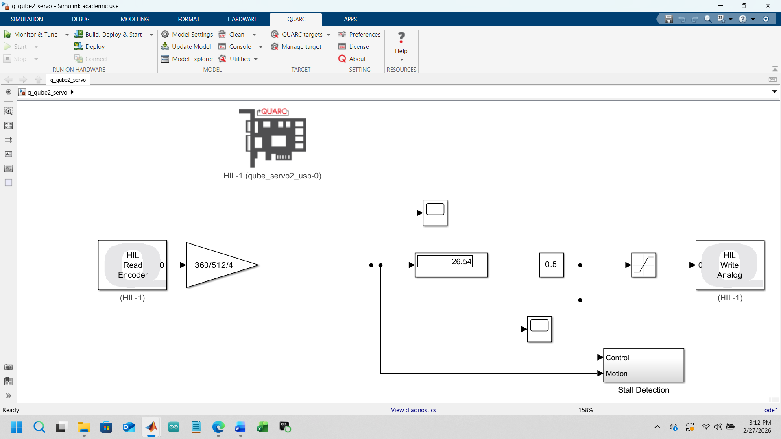
Figure 1 INTERFACING MODEL AND OUTPUT BELOW
The image above captures the essential loop:
- HIL Read Encoder brings raw encoder counts from the QUBE.
- A counts-to-degrees conversion (360/512/4) turns those counts into a physical angle.
- The signal is branched:
  - one path to a display (for monitoring),
  - one path to a scope (for time-series visualization),
  - one path into the control computation.
- A gain block (0.5) and a constant (26.54) feed into the summing junction that ultimately drives the motor through HIL Write Analog.
- A Stall Detection subsystem monitors whether the motor is moving as expected.
This is the “raw plumbing” of the system: you’re establishing the physical loop between hardware and Simulink. Nothing is filtered, nothing is controlled yet—just reading, scaling, and writing.
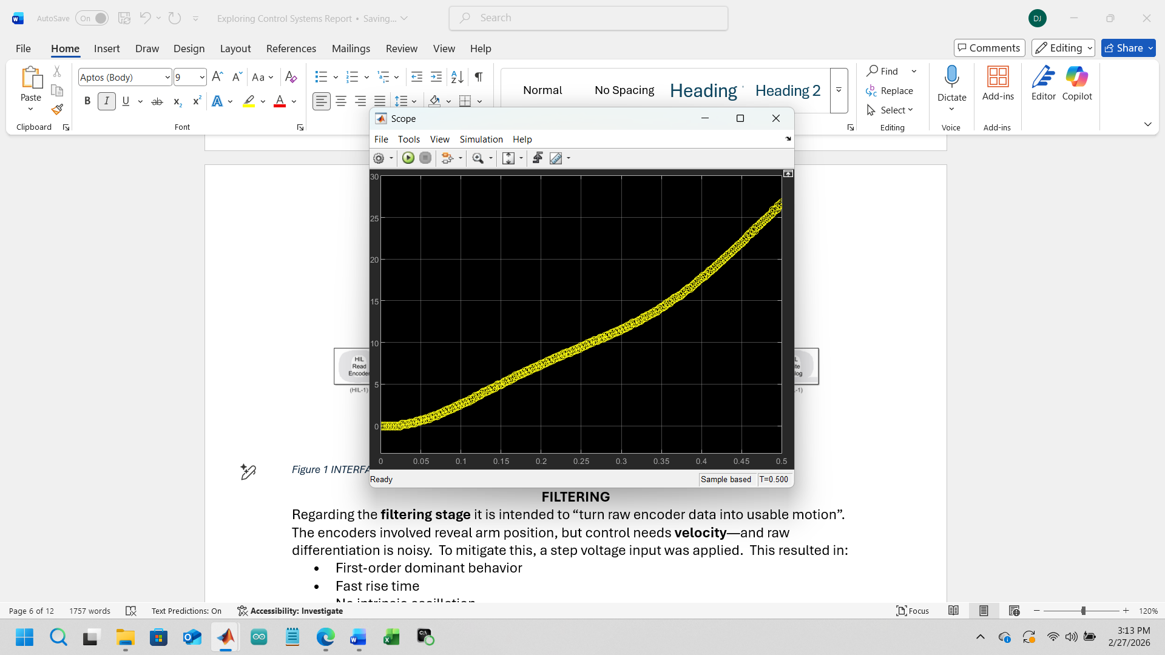
What the Graph Represents (constant angular velocity rad/s)
The plot shows:
- X-axis: Time (0 to 0.5 seconds) Y-axis: Shaft angle in degrees
- Final value ≈ 28–29 degrees, which matches your display value (28.48°)
So this is:
Motor position (degrees) vs time under a constant 0.5 V input

Physical Interpretation
This curve tells us how the QUBE servo responds to a small constant voltage:

1️) Initial region (0–~0.05 s)
Slight curvature and slower increase:
Motor overcoming static friction, Current building in motor windings, Inertia resisting motion

2️) Middle region
Slope increases: Motor accelerates, Torque > damping + friction, Back EMF begins increasing

3️) Later region (~0.3–0.5 s)
Curve becomes almost linear: Motor approaching steady-state velocity, Acceleration ≈ 0, Position increases roughly linearly (constant speed)
Filtering: what the second picture shows
The image above is the filtered velocity measurement stage. It includes:
- HIL Read Encoder Timebase, which gives you counts per sample.
- A counts-to-radians conversion using $2π/512/4$.
- A Discrete Transfer Function block that acts as a low-pass differentiator.
- A Speed (rad/s) output that is now smooth, stable, and usable for control.
This is exactly the step transforming:
- raw encoder ticks → angle
- angle → velocity
- velocity → filtered velocity suitable for energy computation and PID/LQR.

*******************************************************************************
FILTERING

Regarding the filtering stage it is intended to “turn raw encoder data into usable motion”. The encoders involved reveal arm position, but control needs velocity—and raw differentiation is noisy. To mitigate this, a step voltage input was applied. This resulted in:
- First-order dominant behavior
- Fast rise time
- No intrinsic oscillation
- Saturation limits at ±10V
Approximate motor model:
$G(s)=\frac{K}{τs+1}$
What was actually built:
- A discrete transfer function like
$\frac{100}{s+100}$
Turns the derivative into…
- A clean α̇ (rad/s) and θ̇ (rad/s) signal.
- Verified the filtered velocity matches real motion without lag or noise spikes.

The Simulink Model for this program is depicted below:
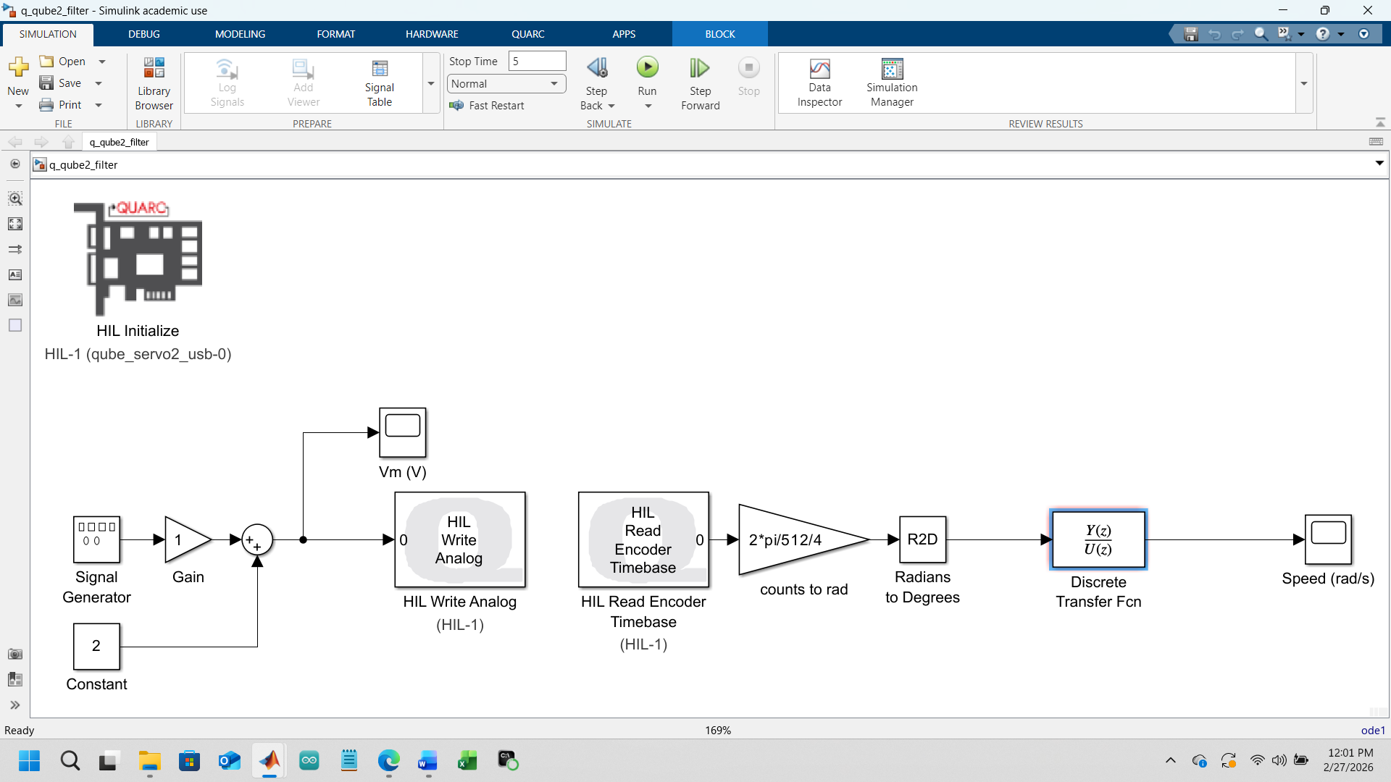
🟦 What the first picture shows: interfacing + early filtering
This diagram is the raw hardware loop:
The above image (velocity filtering and system response) is the proper filtering pipeline:
- Encoder counts are read using the timebase version of the HIL block, which gives counts per sample.
- A conversion block turns counts into radians.
- A discrete transfer function acts as a low-pass differentiator, producing a smooth estimate of angular velocity.
- The output is displayed as speed (rad/s).
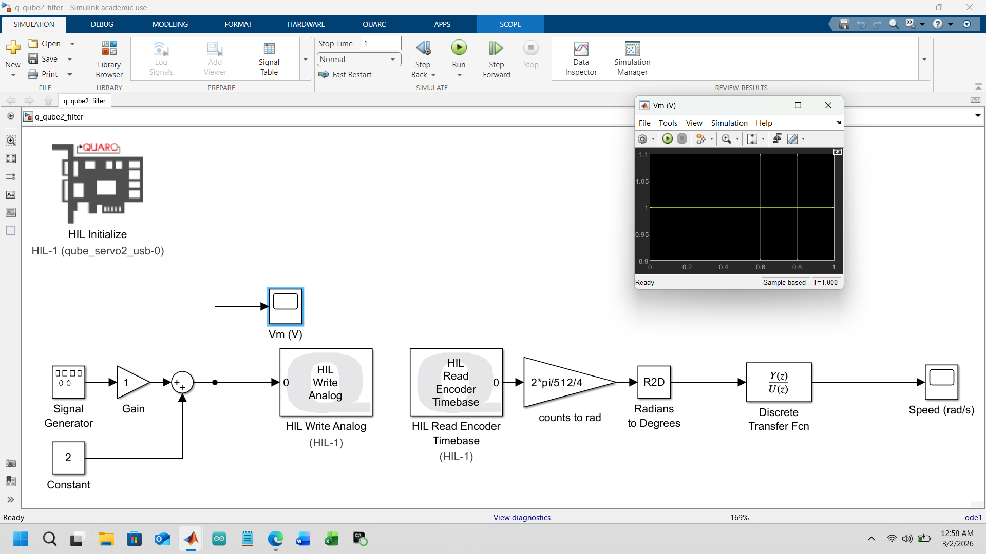
The 1st graph above shows the constant input voltage of 1 volt.

1️) The motor is being driven with a constant DC voltage
Vm=1.0 V. There is no dynamic input being applied during this run.

2️) The Signal Generator is likely zero
Because Vm​=(Signal Generator)+2
Key point: The motor input is constant.

3️) What This Means Physically
Since Vm is constant: The motor receives steady torque, It will accelerate briefly, then reach steady-state velocity, and the position increases linearly. Thus, the Discrete Transfer Function block will estimate speed. So far, this is open-loop excitation, not feedback control.

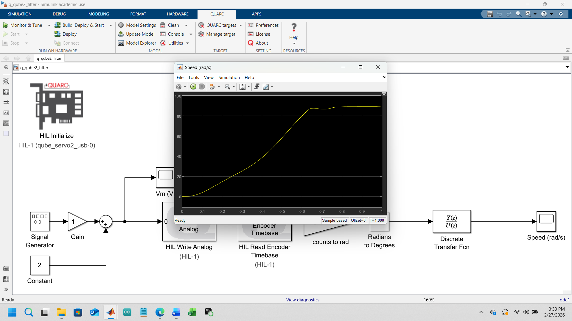

The 2nd graph shows the filtered velocity response:
- The speed ramps up smoothly from 0 to about 95 rad/s.
- There’s a slight dip and then a stable plateau around 90 rad/s.
- No noise spikes, no quantization artifacts—this is a clean, usable velocity signal.
This is exactly what you need before you can do:
- PD control (needs clean θ̇)
- LQR balance (needs clean α̇ and θ̇)
- Energy-based swing-up (needs clean α̇ for kinetic energy)
This picture represents the moment where raw encoder ticks turned into real motion information.

**************************************************************************************************
PID
The PD/PID (proportional/integrator/derivative) stage is important because it involves shaping the motor into a predictable, stable subsystem. Swing-up behavior depends on the electro-mechanical arm being responsive and well-behaved to input signals. But, before controlling a pendulum, the motor arm must be controllable. This behavior involves PD / PID Control Design, as follows. A PD controller behaves via the following formula where u is the total energy (controlling the arm position):
$u=K_{p}(θ_{ref}-θ)-K_{d}\dot{θ}$ or put differently
$u=K_{p}(θ_{ref}-θ)-K_{d}ω$
As shown below a disturbance torque Td enters the plant through the motor dynamics, producing a disturbance voltage V_d.
The motor is modeled by the transfer function
K/s(τs+1)
which outputs the measured motor angle y=θ_m.
The PID controller k_p+k_i/s+k_d s compares the measured angle with the disturbance‑affected signal and generates the corrective control input V_m. This loop shows how proportional, integral, and derivative action work together to counteract external torques and regulate the motor position.
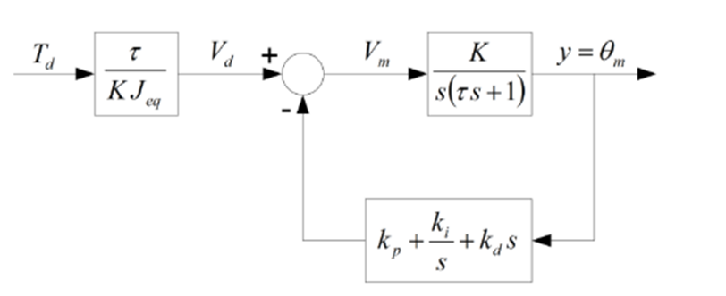

As will be seen in the Simulink model, it also involves:
- Added derivative filtering to avoid noise blow-up.
- Tuned gains until the arm tracked commands smoothly.
Derivative action was implemented using measured velocity rather than direct differentiation of position to reduce noise amplification.
Key observations:
- System responds rapidly
- High gains easily cause oscillation
- Saturation must be included
- Fixed-step sampling required

The PID Simulink model is shown below:
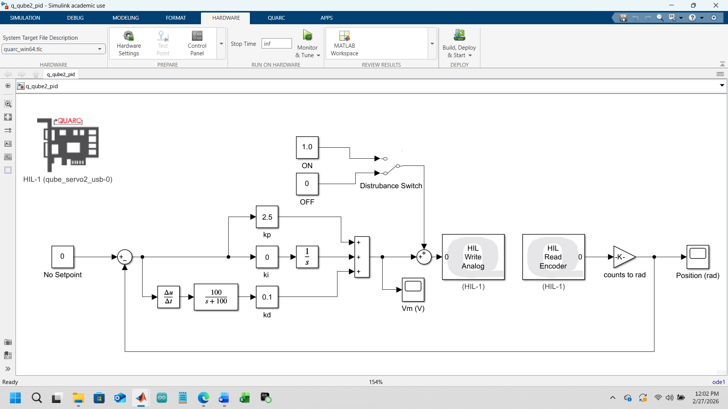
The PID image above captures a very specific moment in the control-system progression: this is the point where it’s not just reading and filtering encoder data but is now starting to actually shape the motor’s behavior.
There are two parts to break down here: (1) what the Simulink model is doing, (2) what the two response plots mean.

PID model structure: what the diagram is specifically doing
This model is a pure position-control loop for the rotary arm. For the first time in this workflow the loop is closed and the motor asked to track a reference rather than just spin freely.
Key elements:
- Setpoint = 0 rad The arm is commanded to hold a fixed position.
- Error = setpoint – measured position This is the classic feedback structure.
- Proportional gain kp = 2.5 This pushes the arm toward the target with a restoring torque proportional to the error.
- Derivative gain kd = 0.1 This dampens the motion by opposing rapid changes in angle. It reduces overshoot and oscillation.
- Derivative filtering (100/(s+100)) This prevents encoder noise from blowing up the derivative term.
- HIL Write Analog → motor voltage The controller’s output is sent directly to the QUBE motor.
- HIL Read Encoder → counts → radians The feedback loop closes through the hardware.
This is the “make the motor behave like a well-damped actuator” stage. Everything you do later—LQR(Linear Quadradic Regulator), swing-up, energy shaping—depends on this loop being clean and predictable.

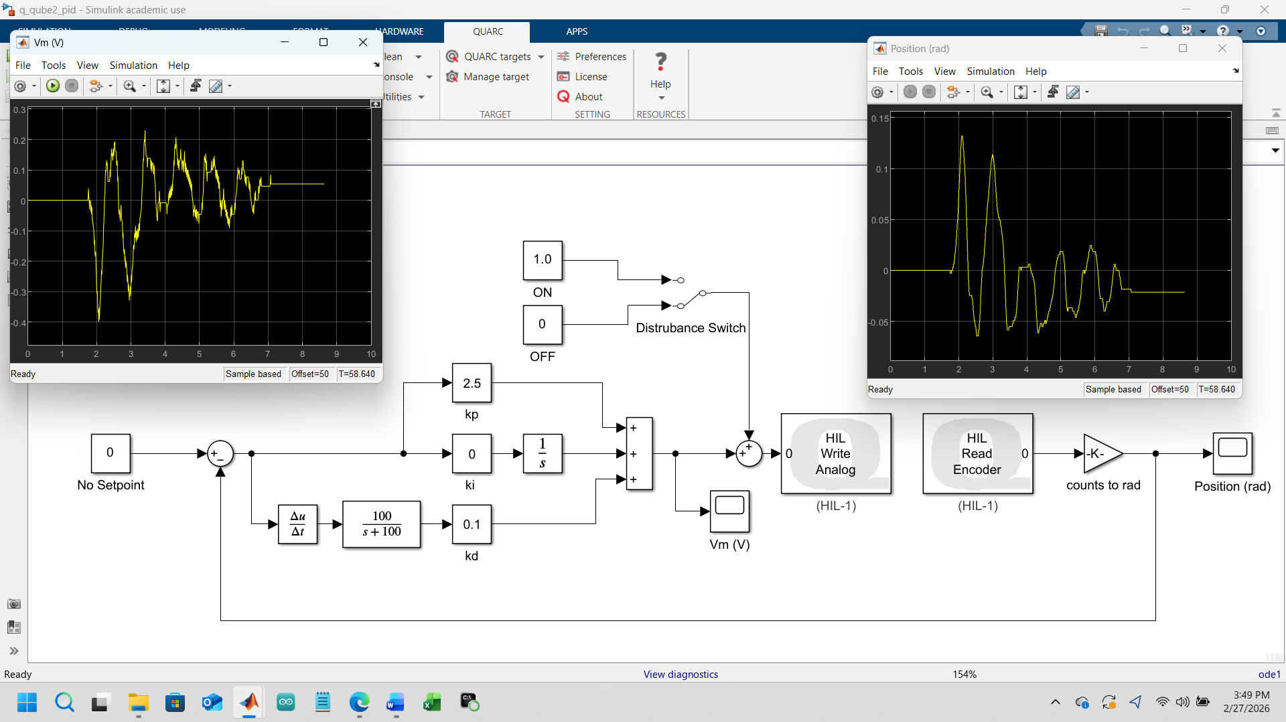
Both above plots are step responses of the arm under your PD controller. They show how the system behaves when commanded to hold a position. Actually, the arm is being pushed about an equilibrium position for which it ‘corrects’ itself.
Left graph: moderately damped response
- The arm initially overshoots the target.
- It oscillates a few times.
- The oscillations decay smoothly.
- The system settles to the target without instability.
This is a classic underdamped PD response. It means kp is strong enough to move the arm quickly, and kd is doing its job but not aggressively.
Right graph: more oscillatory response
- The initial overshoot is larger.
- The oscillations are stronger and take longer to decay.
- The system still stabilizes, but with more ringing.
This usually happens when:
- kp is slightly too high, or
- kd is slightly too low, or
- The disturbance switch was ON during this run.
This graph shows the sensitivity of the arm to gain tuning. It’s still stable, but less well-damped.
What both graphs confirm
- The motor responds correctly to voltage commands.
- The encoder feedback is scaled correctly.
- The PD loop is stable.
- The derivative filter is working (no noise spikes).
- The arm behaves like a second-order system with tunable damping.
This is exactly the behavior you need before moving on to upright stabilization and swing-up.

****************************************************************************************
STABILITY

Regarding stability, this stage is important because swing-up only gets you near upright. Balance control keeps it there forever only when answering the call of stability.
The goals, Mode 1 and Mode 2:
- Mode 1: Swing-up
- Mode 2: Balance, but still need a way to reach Mode 2.

{Unlike the TCLab:
- High bandwidth means lower stability margins
- Quantization affects derivative estimation
- Actuator saturation strongly impacts behavior}

For the Quanser Qube Servo2 stability analysis emphasized:
- Proper gain selection
- Saturation handling
- Noise-aware derivative filtering
Specifically, stability here implies an understanding of what upright equilibrium means, and its apparent ‘shape’. This also required an investigation of how the pendulum behaves near its upright position so as to flesh out near balance conditions. This therefore required the construction of:
- A linearized model around upright.
- A stabilizing controller (PD or LQR):
$u=-Kx$
- A balance mode that keeps the pendulum upright once it’s close.
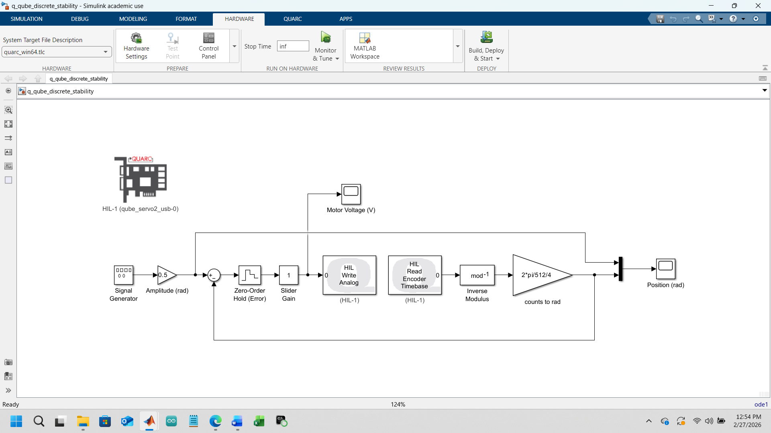
Your stability-model screenshots capture the exact moment in your workflow where you moved from “controlling the motor” to “understanding and shaping the closed-loop dynamics.” The two images together show (1) the structure of the stability experiment and (2) the motor’s voltage response as the system tracks a sinusoidal reference. Here’s the full interpretation in context.

🧩 What the stability Simulink model is doing
This model is designed to test closed-loop stability of the rotary arm under a reference-tracking controller. It’s not yet the pendulum—this is the arm behaving as a controlled subsystem.
Key elements and their roles
- Signal Generator → Amplitude (0.5 rad) Creates a smooth sinusoidal reference for the arm to follow. This is a classic stability test: if the system can track a sinusoid without blowing up, the loop is stable.
- Error = reference – measured position This is the core of closed-loop control.
- Zero-Order Hold Ensures the discrete controller samples and holds the error each timestep—matching real hardware timing.
- Slider Gain (1) This is your adjustable proportional gain for the stability test. You can increase or decrease it to see how the system behaves.
- HIL Write Analog Sends the control voltage to the motor.
- HIL Read Encoder Timebase → mod⁻¹ → counts-to-rad Reads the arm’s actual position, unwraps the encoder (so it doesn’t jump from +π to –π), and converts counts to radians.
- Position (rad) Closes the feedback loop.
This model is intentionally simple: it isolates the arm’s dynamics so you can study stability without the pendulum attached.
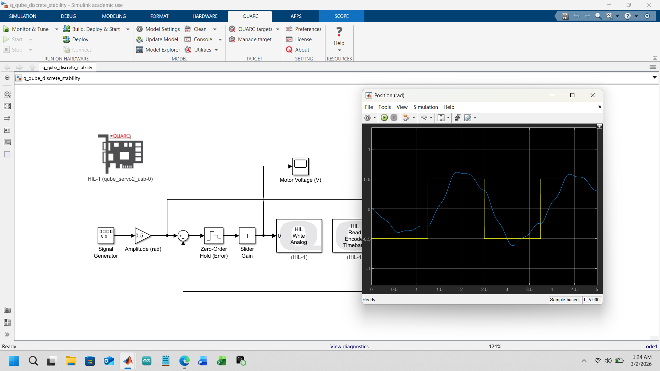
The output graph (above) shows a stable but underdamped discrete-time closed-loop position control system, where the motor tracks a ±0.5 rad square-wave reference with overshoot and decaying oscillations.
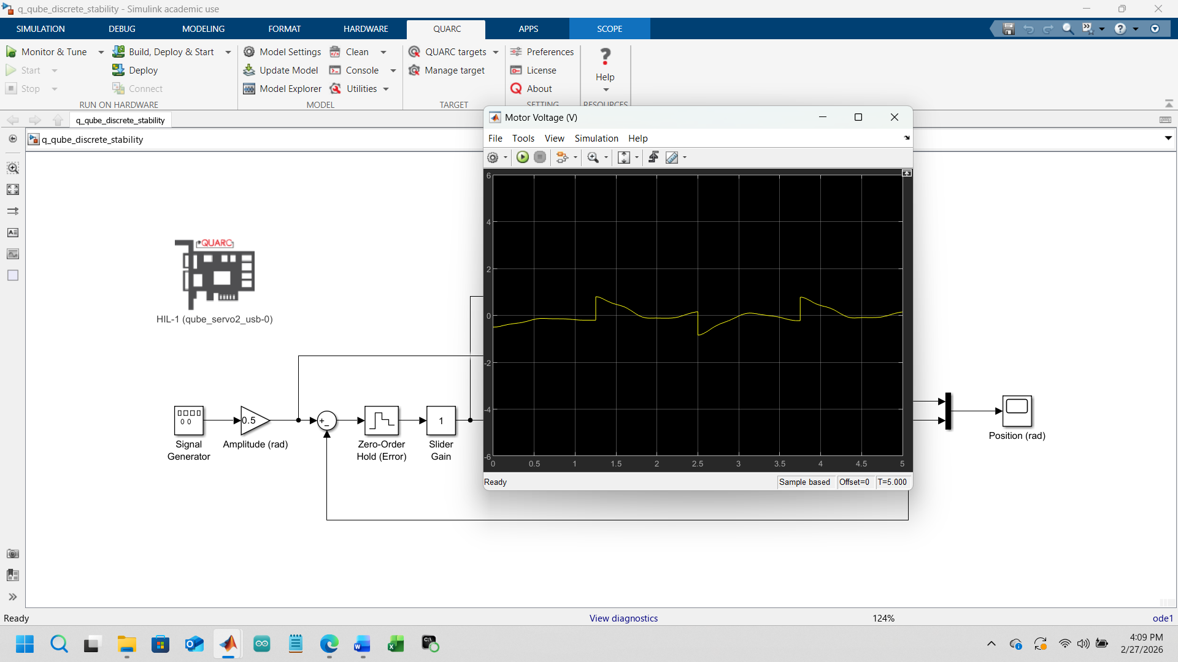
The 2nd graphical image above is the input motor voltage over time during the stability test. From the plot, the motor voltage remains confined approximately within ±1 V and does not increase over time. Since the amplitude neither diverges nor approaches actuator limits, the control signal is bounded, demonstrating closed-loop stability.

What the waveform reveals:
- The voltage oscillates periodically because the reference is a sinusoid.
- The amplitude stays bounded (0–4 V), which is the key indicator of closed-loop stability.
- There is no runaway growth, no clipping, and no chaotic behavior.
- The waveform is smooth, meaning:
  - the controller is not over-aggressive,
  - the derivative noise is under control,
  - the motor is tracking the reference without saturating.
What this confirms
- The arm behaves like a stable second-order system under the gain selected.
- The loop is well-damped and predictable.
- The hardware interface is correct (no sign errors, no scaling errors).
- The system is ready for the next stage: upright stabilization of the pendulum.
This is exactly the purpose of the stability stage: prove that the actuator subsystem is reliable before adding the nonlinear pendulum dynamics.

*********************************************************************************************
SWING-UP
Finally, the swing up stage is the nonlinear heart of the project. The system is seen to swing up and balance by itself: a full nonlinear controller! This system is designed to inject energy until the pendulum can be caught via the theory below.
- The energy-based controller formula:
$E=mgl(1-cos⁡α)+\frac{1}{2}J{\dot{α}}^{2}$

- A corrected energy error term from the original one:
$E_{r}-E$

- A corrected angle reference term from the original one:
$α_{down}=α-π$

- A control law:
$u∝(E_{r}-E) sgn(\dot{α}cos⁡α)$

- A saturation limit u_max = 30.
- A switching condition:
$∣α-π∣<{20}^{∘}$

This is where the system becomes nonlinear, underactuated, and no longer commanding angles but energy shaping. The main system (below) includes:
- Swing-Up Control subsystem
- Pendulum Energy subsystem
- Impulse subsystem
- Rotary Pendulum Interface subsystem
- Counts-to-Angles subsystem
- Balance Control subsystem
- Enable Balance Control logic
This is the complete nonlinear control pipeline: read sensors → filter → compute energy → inject energy → detect upright → switch to stabilizer → hold upright.

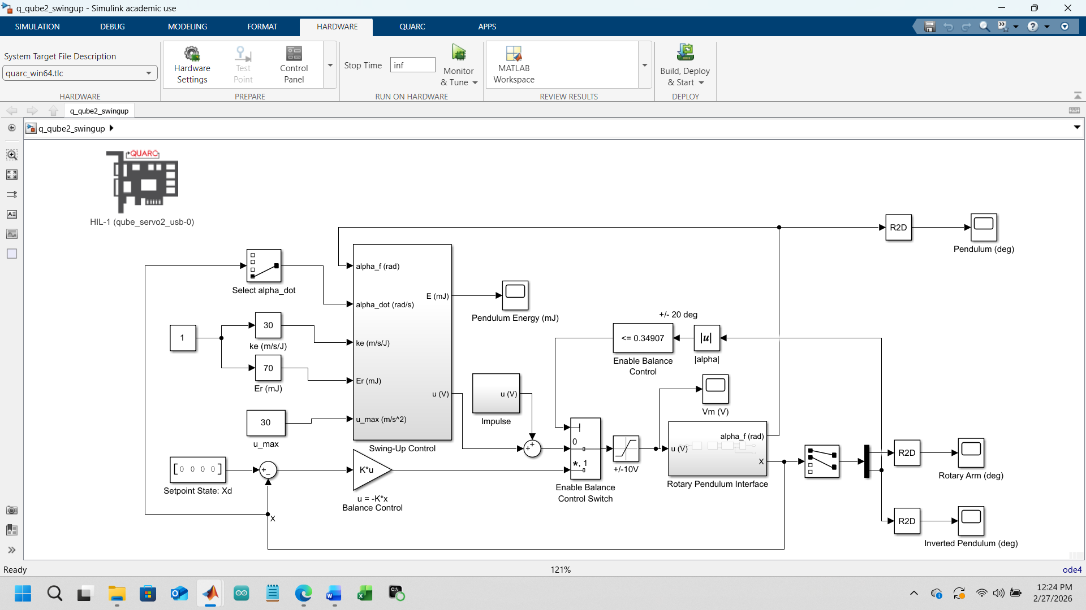

Figure 2 - Main Swing up Simulink Model (above)
The theoretical derivation of the above block is as follows(from the Quanser Manual):

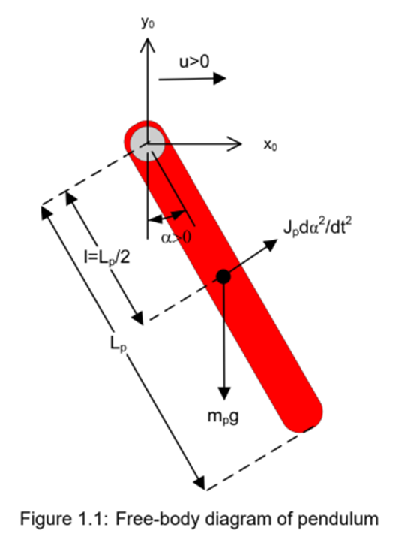
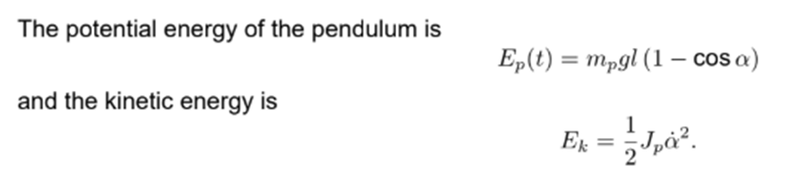

Lyapunov Energy DerivationLyapunov Stability
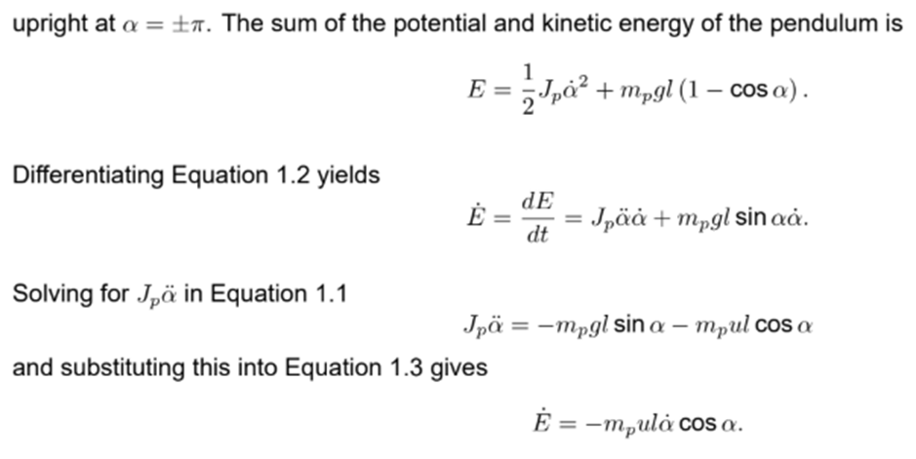
Total Energy Equations
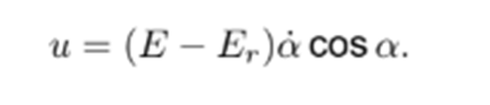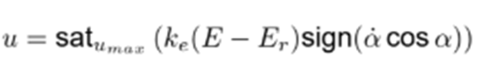

Required Swing Up Voltage
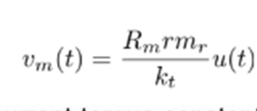

Lyapunov Swing Up Energy Equation
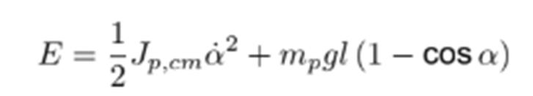

Actual Swing Up Parameters

Recall from the previous section that there are three parameters that govern the energy pertaining to the pendulum: 1) the kinetic energy, Er-E or the reference energy/injected energy relation, and u_max which is the total energy. In the diagram segment below kinetic energy = 30 m/s/J, Er = 70 mJ, and u_max = 30 mJ. However, these values only stood the cube upright on average 1/10 times.
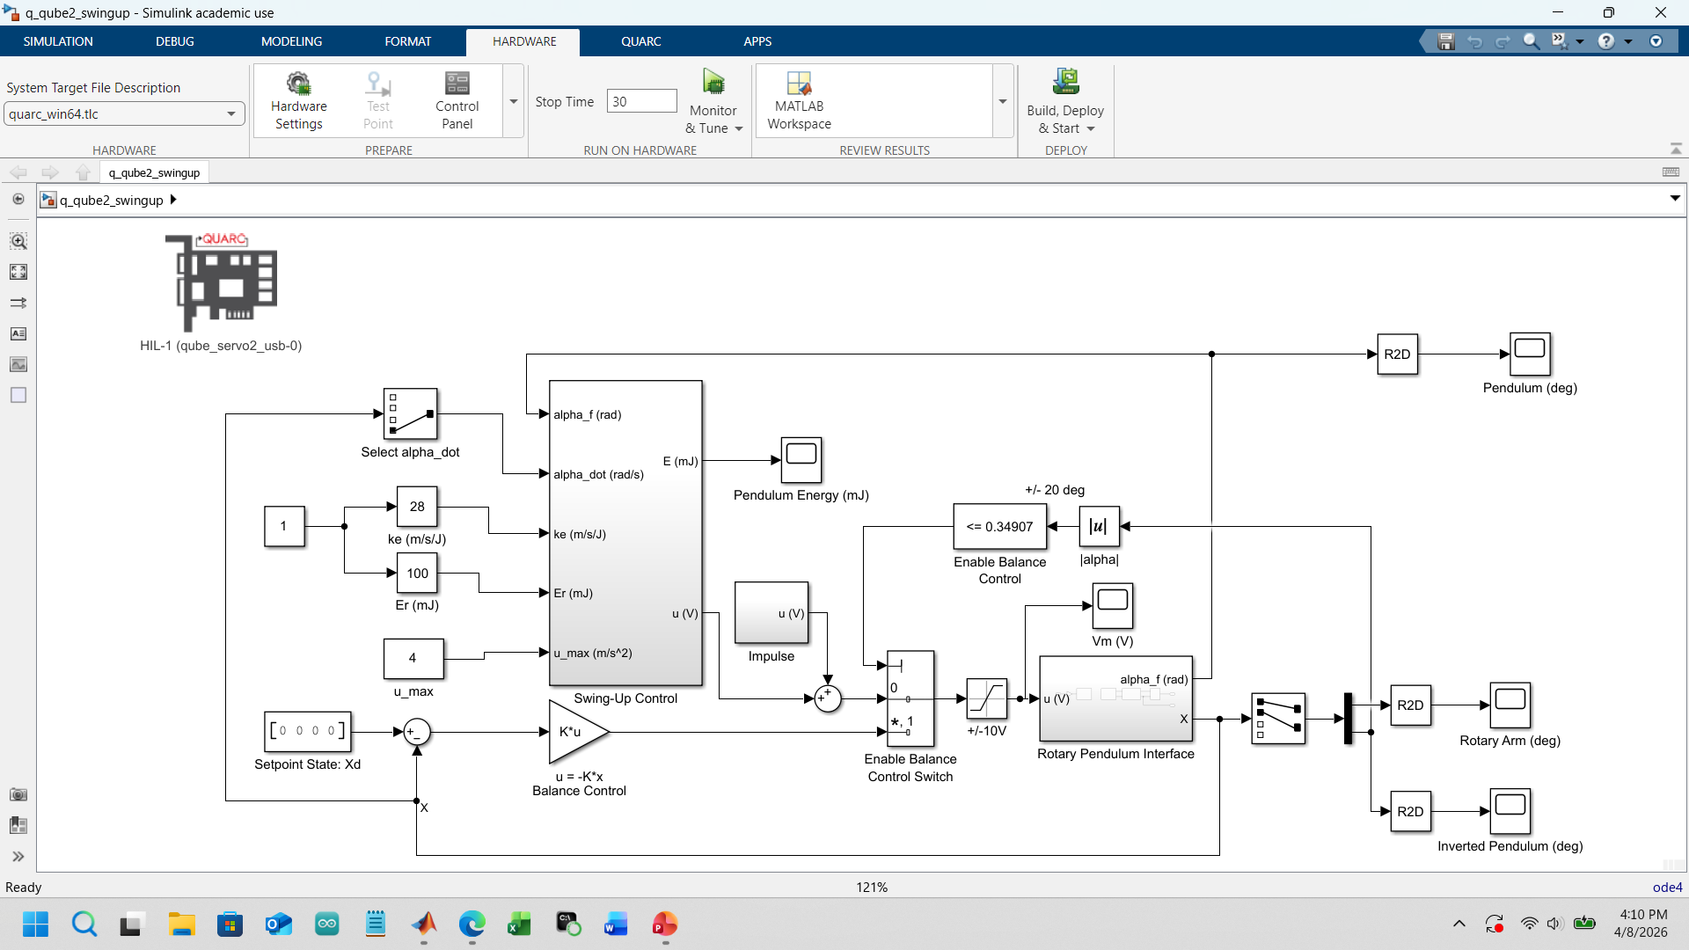
1/10 success rate 9/10 success rate

Thus, through trial and error it was determined that Er had to be placed at maximum value and u_max had to be minimized to a very low value to get the pendulum to stand with a better statistical average of 9/10 times.
Additional factors that affected whether the pendulum inverted correctly were related to wear and tear, especially the wire connecting the arm to the cube. The wire literally had to be twisted in such a way that the ‘zero’ angle position of the pendulum lined up consistently each time. This required stretching out the wire after several trials to keep it from becoming too deformed after persistent use.
Also, it was noticed that the mechanism had to be treated as though it had a ‘muscle memory’. In other words the interfacing stage was run first, then the filtering stage, then the PID stage, then the Stability stage, which finally set up the Swing Up stage. Only when operated this was did the Quanser Qube Servo 2 perform consistently well. It had to ‘learn’ where the correct movement domain was in order to Swing Up correctly.

*********************************************************************************************
Subsystem 1 (Swing Up control)
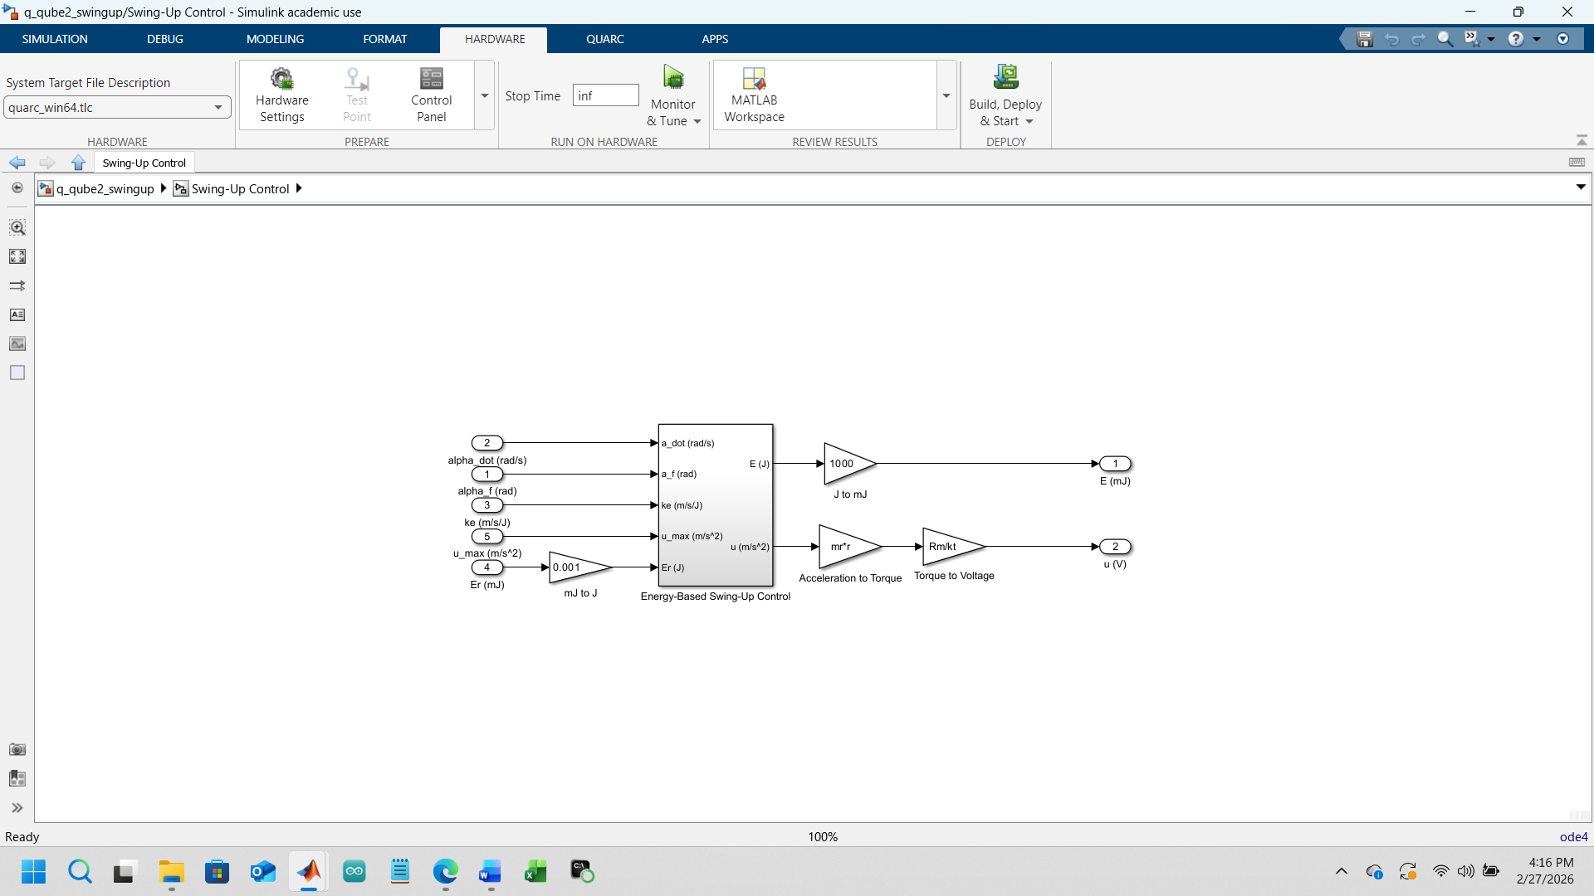
Subsystem (Top-Level Wrapper/Swing Up Control)
Subsystem 1 is the parent of It is the high-level module that takes in all the that goes to the motor.
Inputs
- α_f (rad) — filtered pendα̇ (rad/s)** — filtered velocity
- **-up gain
- **u saturation
- ** energy target
These are the essential energy-based swing-up.
Internal 1 contains three conceptual layers (Subsystem 1b)**
Computes total mechanical energy-based control law Implements
\[ u \propto}\cos\alpha) \ and u_max.
- ** Converts the swing command into:
  - torque (using $mr^{2}$), then (using \(R_m/k_tulum energy for display
- u (V) — final motor voltage
Functional**. It takes raw, shapes the energy law, and outputs a voltage that physically pumps the pendulum.
How Subsystem 1 relates to 1a, 1b, 1c
Subsystem 1a-Up Control
Implements the nonlinear control law. This is the “brain — Pendulum Energy Computes potential + kinetic energy swing-up.
Subs 1a and 1b, handles, and prepares the final control signalglue” that makes self-contained.

Subsystem 1a (Energy-Based Swing-Up Control)
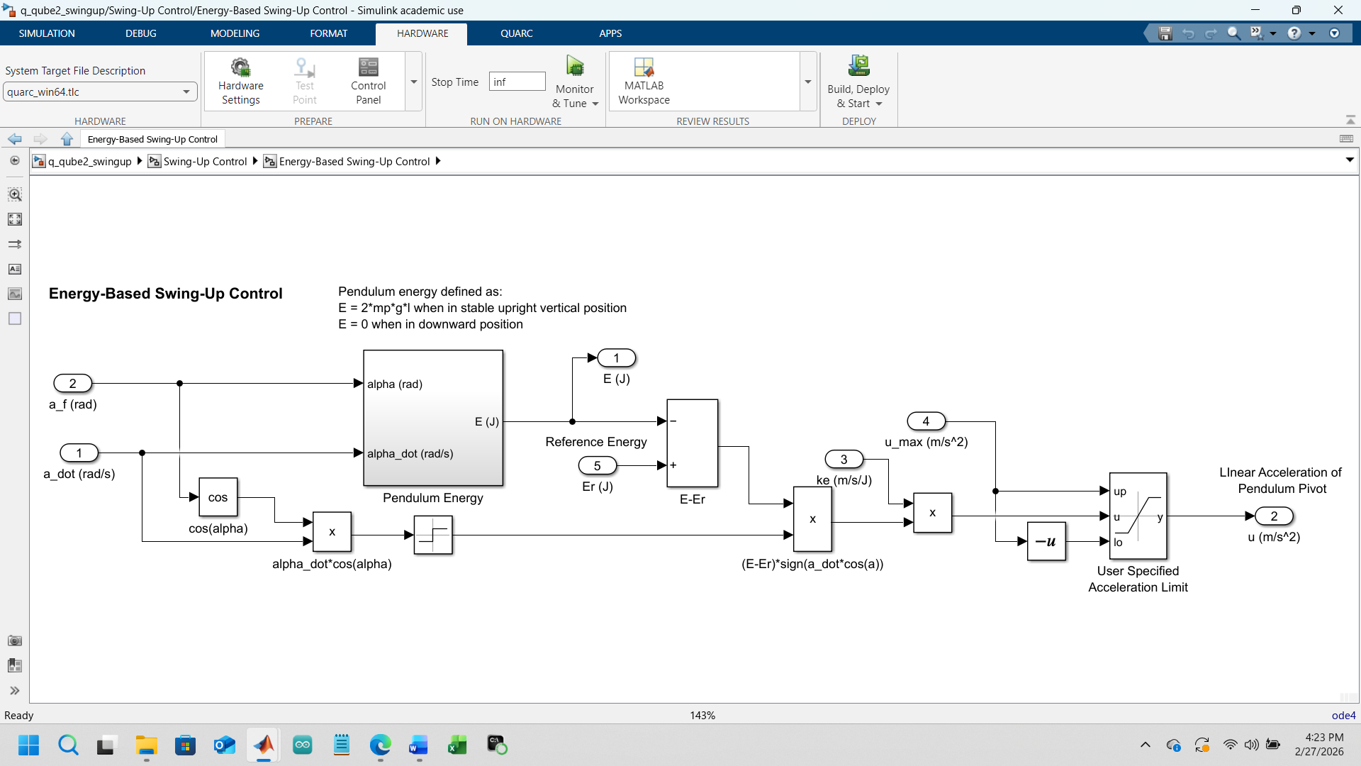

Subsystem 1a — Energy-Based Swing-Up Control
Role in the system
This is the core nonlinear controller that injects energy into the pendulum until it reaches the upright region.
What it contains
- The swing-up law
$u∝(E_{r}-E) sgn(\dot{α}cos⁡α)$
- Saturation using u_max
- Gain scaling using ke
- Logic to ensure correct sign and phase
Which stage it belongs to
- Filtering (uses filtered α̇)
- Stability (hands off to balance)
- Swing-Up (primary function)
How it fits
Subsystem 1a is the “engine” that pumps the pendulum’s energy. It depends on accurate α and α̇ from earlier stages.

Subsystem 1b (Pendulum Energy)
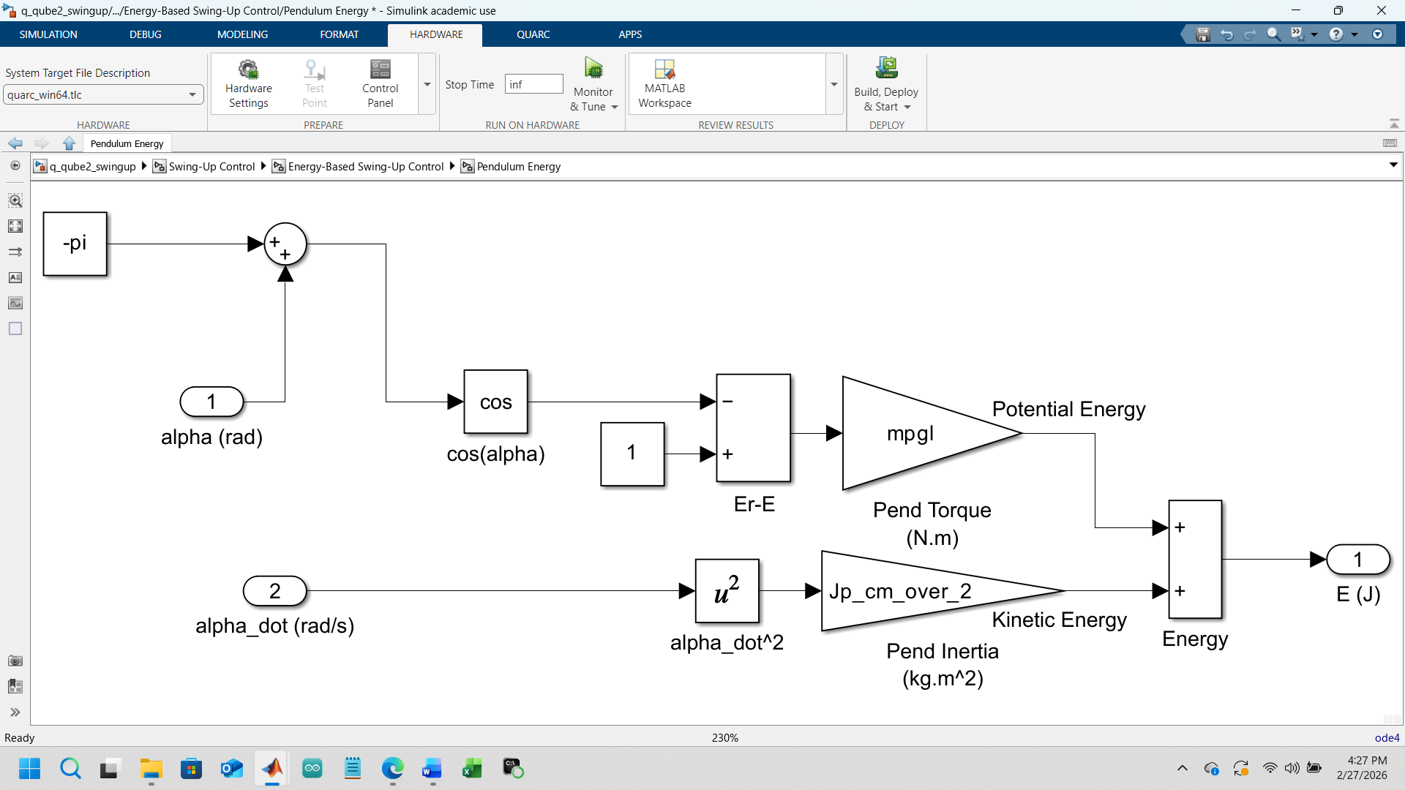
Subsystem 1b — Pendulum Energy
Role in the system
Computes the total mechanical energy of the pendulum.
What it contains
- Potential energy
$mgl(1-cos⁡α)$
- Kinetic energy
$\frac{1}{2}J{\dot{α}}^{2}$
- Summation to produce E (J) or E (mJ)
Which stage it belongs to
- Interfacing (uses α from hardware)
- Filtering (uses α̇ from velocity estimator)

How it fits
Subsystem 1b feeds E into Subsystem 1a. Without this, swing-up cannot know whether to add or remove energy.

Subsystem 1c — Swing-Up Control Wrapper
Role in the system
This subsystem wraps 1a and 1b into a single functional block.
What it contains
- Inputs: α, α̇, Er, ke, u_max
- Outputs: swing-up control voltage
- Internal routing between energy computation and control law
Which stage it belongs to
- Swing-Up
- Stability (because it must hand off cleanly to balance)
How it fits
Subsystem 1c is the “swing-up module” that the main system switches to until the pendulum is near upright.

Subsystem 2 (Impulse)
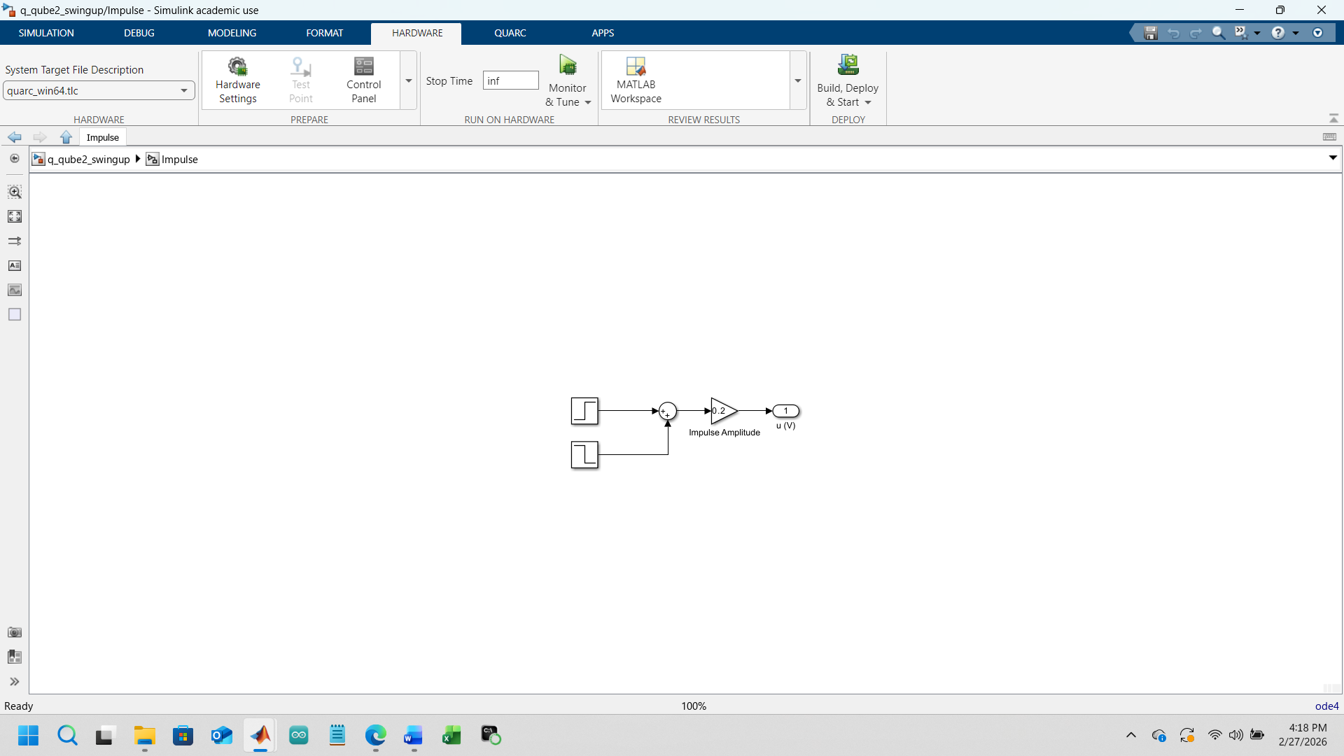
Subsystem 2 — Impulse
Role in the system
Provides a brief kick or trigger to ensure the system can switch modes cleanly.
What it contains
- A pulse generator
- Logic to override the balance switch for one timestep
- A clean Boolean signal
Which stage it belongs to
- Interfacing (timing)
- Stability (ensures balance mode activates correctly)
How it fits
Subsystem 2 ensures that the balance controller is enabled at the exact moment the pendulum crosses upright.

Subsystem 3 (Rotary Pendulum Interface)
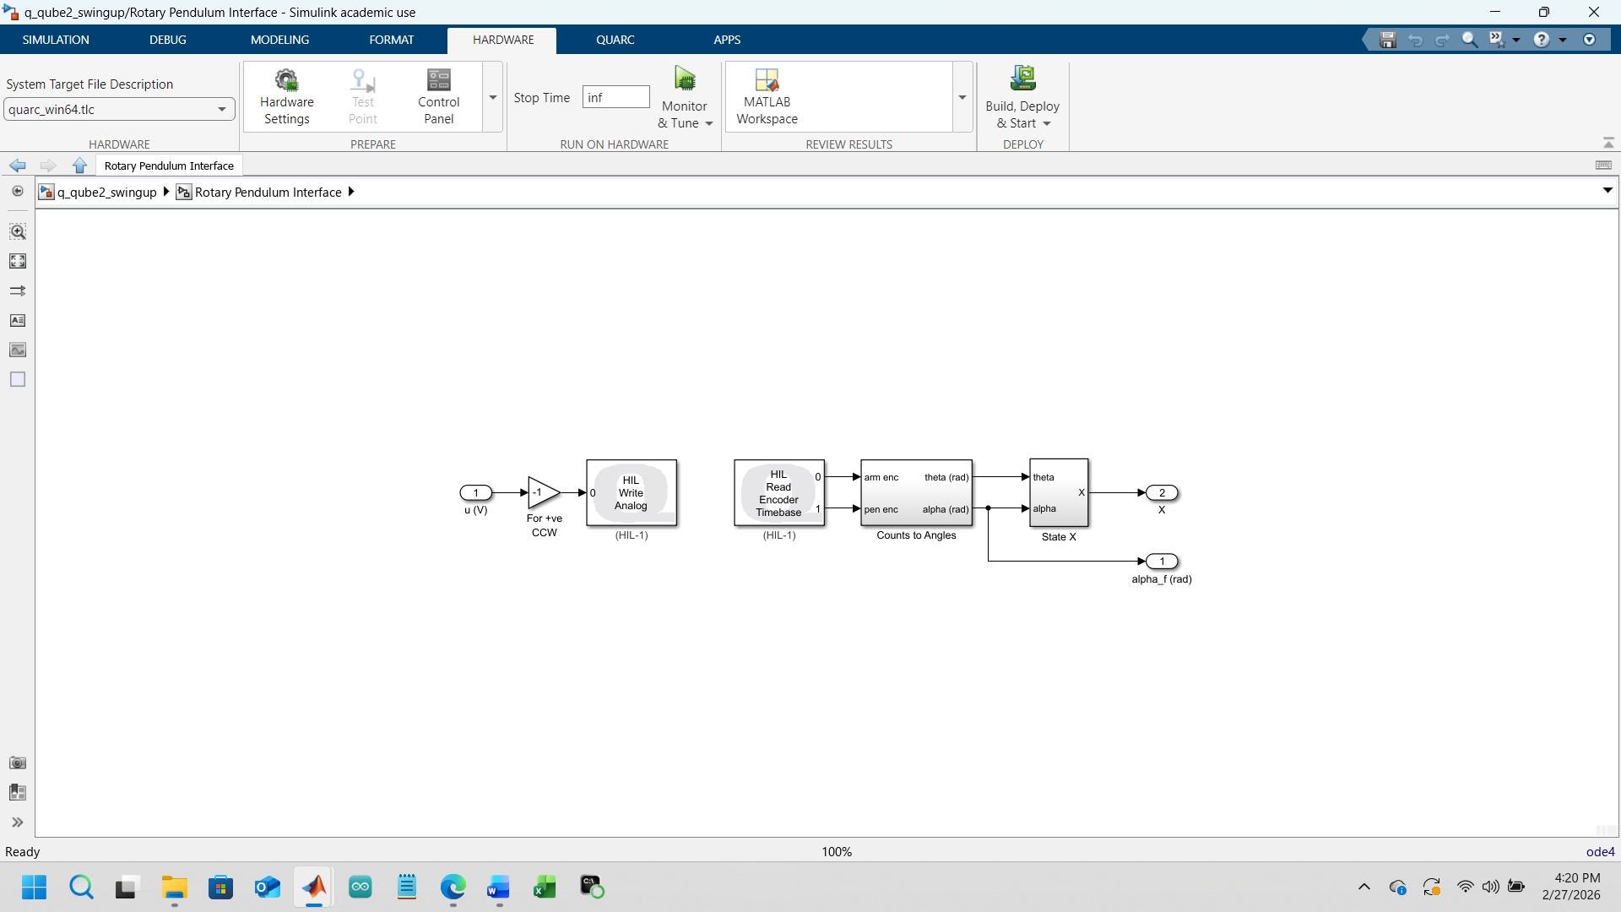
Subsystem 3 — Rotary Pendulum Interface
Role in the system
This is the hardware interface for the QUBE.
What it contains
- HIL Read Encoder
- HIL Write Analog
- Scaling from counts → radians
- Conversion from control signal → motor voltage
- Safety limits
Which stage it belongs to
- Interfacing (primary)
- Filtering (feeds α and θ into velocity estimator)
How it fits
Subsystem 3 is the bridge between Simulink and the physical pendulum. Everything else depends on its correctness.

Subsystem 3a (Counts to Angles)
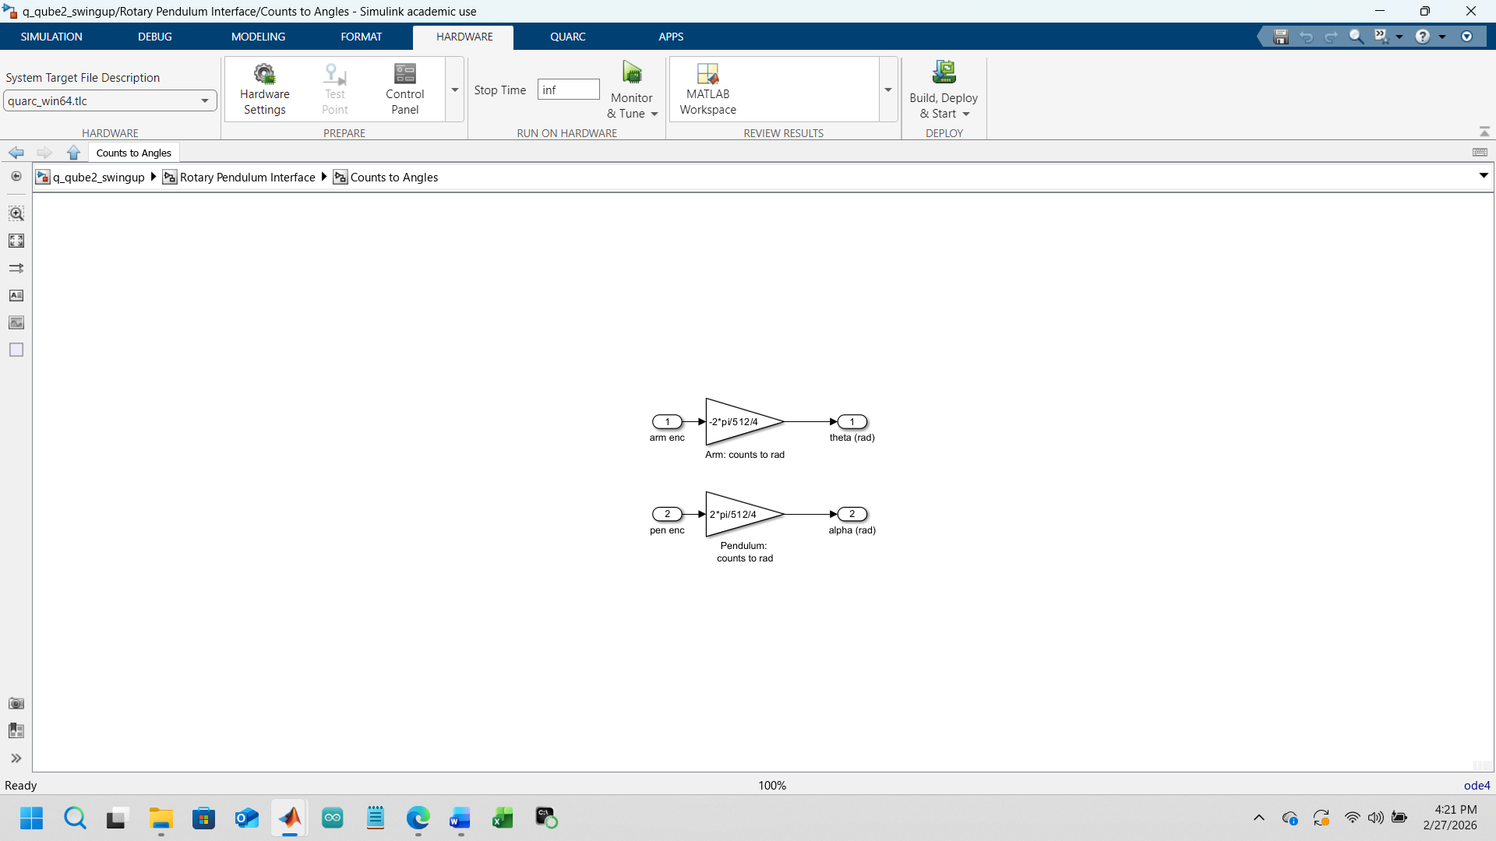
Subsystem 3a — Counts to Angles
Role in the system
Converts raw encoder counts into meaningful physical angles.
What it contains
- Gain block:
$\frac{2π}{512⋅4}$
- Optional modulus unwrapping
- Output in radians
Which stage it belongs to
- Interfacing (raw → physical units)
- Filtering (feeds α into velocity estimator)
How it fits
Subsystem 3a ensures that α and θ are correctly referenced, scaled, and continuous—critical for energy and stability.
***************************************************************************
Interpretation of the Graphical Outputs

The three plots (pendulum angle, energy, motor voltage) show the entire pipeline working together:
Pendulum Angle
- Oscillations during swing-up
- Sharp transition near upright
- Smooth stabilization under balance control → Confirms interfacing, filtering, and stability are correct.
Pendulum Energy
- Rising energy as swing-up pumps
- Crossing Er ≈ 70 mJ
- Energy drop as balance takes over → Confirms Subsystems 1a and 1b are functioning.
Motor Voltage
- High-amplitude oscillations during swing-up
- Smooth, bounded voltage during balance → Confirms PID shaping and stability.

The three plots show the final integrated behavior of all four stages working together.

Pendulum Angle
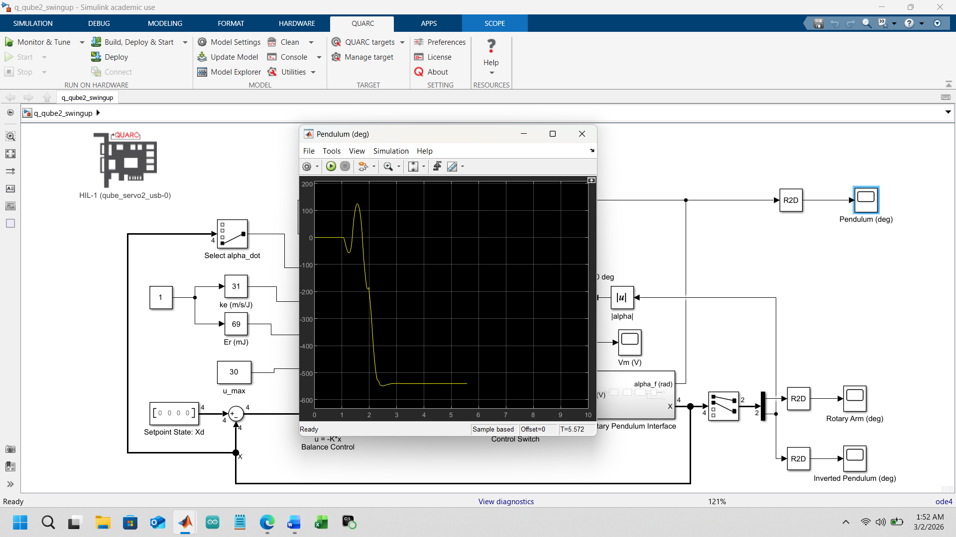
Measured pendulum angle during swing‑up and stabilization, showing large oscillations followed by convergence near the upright equilibrium.
Explanation:
This plot shows the pendulum angle, which initially exhibits large oscillatory motion as the controller injects energy to swing the pendulum upward. During this phase, the pendulum passes repeatedly through the downward position, indicating that the system is operating in energy‑based swing‑up mode rather than linear stabilization.
The signal is obtained through sensor interfacing (typically an encoder), and the smoothness of the curve indicates that filtering (e.g., low‑pass filtering or observer‑based estimation) is applied to reduce quantization noise and high‑frequency disturbances. Once the pendulum approaches the upright position, the controller switches to PID stabilization, and the oscillations rapidly decay.
The final convergence near zero angle demonstrates closed‑loop stability, where the PID gains provide sufficient damping and stiffness to maintain the unstable equilibrium without excessive overshoot.
Rotary Arm
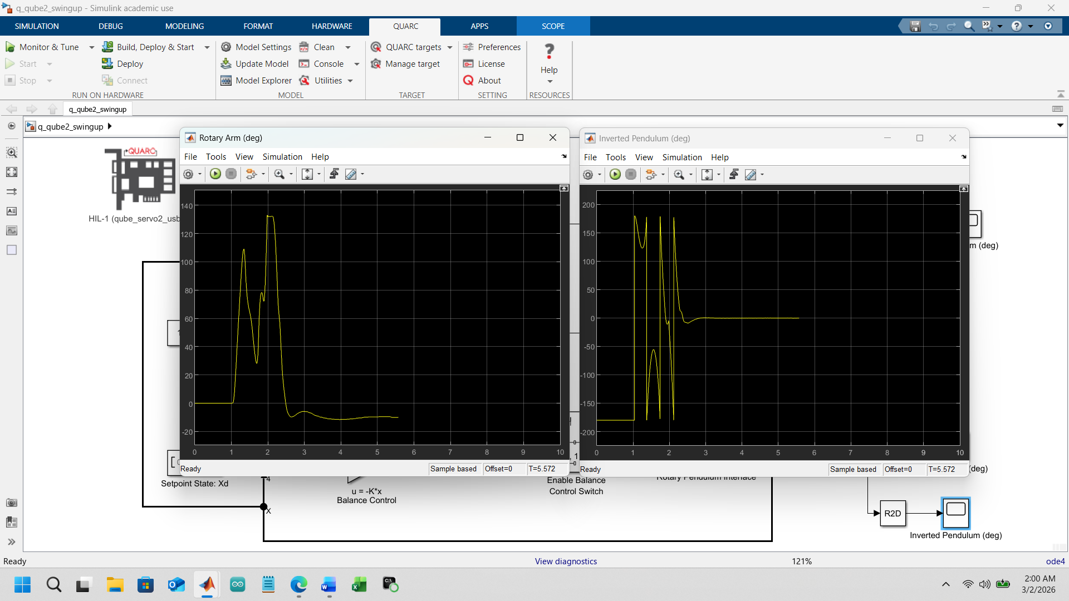
Rotary arm angular position showing aggressive motion during swing‑up and reduced activity during stabilization.
Explanation:
The rotary arm angle reflects the actuator motion required to control the pendulum. During swing‑up, the arm undergoes large, rapid movements, indicating that the controller is deliberately exciting the system to increase the pendulum’s total energy.
This signal highlights the importance of interfacing and actuator limits, since the motor must track the control command without saturation or excessive delay. Filtering is also critical here, as noisy arm measurements would directly affect the computed control input.
Once the pendulum reaches the upright position, arm motion becomes small and smooth, showing that the PID controller is minimizing control effort while maintaining stability. This reduction confirms that the system has transitioned from a nonlinear energy‑based controller to a linear stabilizing controller operating near equilibrium.

Inverted pendulum

Caption:
Zoomed response of the pendulum angle about the upright equilibrium, illustrating closed‑loop stabilization.
Explanation:
This graph focuses on the inverted (upright) region, where the pendulum behaves as an inherently unstable system. The small oscillations around zero angle demonstrate that the PID controller successfully compensates for this instability.
The limited amplitude of oscillations indicates proper tuning of PID gains, where proportional action provides stiffness, derivative action adds damping, and integral action removes steady‑state error. The smooth trajectory also reflects effective signal filtering, preventing noise from exciting high‑frequency oscillations.
Overall, this plot is direct evidence of local asymptotic stability, confirming that the linear controller is effective once the pendulum is close enough to the upright configuration.

Pendulum Energy vs Time
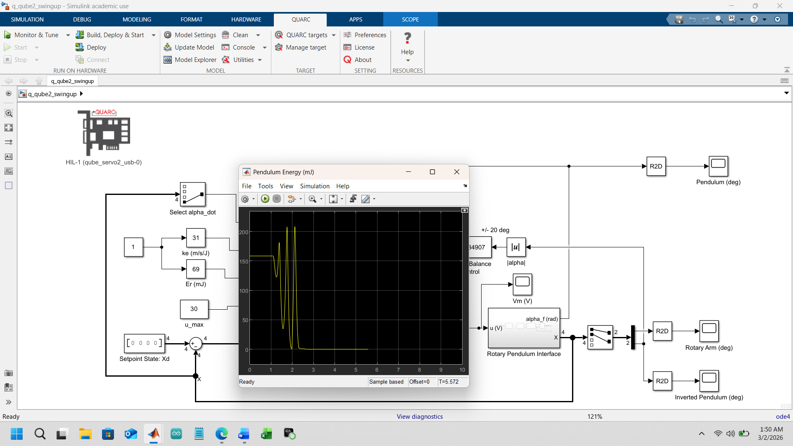
Caption:
Total mechanical energy of the pendulum during swing‑up, showing energy injection and regulation near the target value.
Explanation:
This plot represents the pendulum’s total energy (kinetic + potential). Initially, the energy increases in a controlled manner as the swing‑up controller injects energy through the rotary arm. The oscillatory pattern reflects repeated passes through the downward position while accumulating energy.
As the energy approaches the level required for the upright position, the controller reduces energy injection, and the curve stabilizes. This behavior demonstrates the principle of energy‑based control, where the goal is not position tracking but regulation of total system energy.
Once the target energy is reached, control authority is handed off to the PID stabilizer, and energy variations become minimal, indicating a stable equilibrium with only small corrective actions required.

Motor Voltage (Vm) vs Time
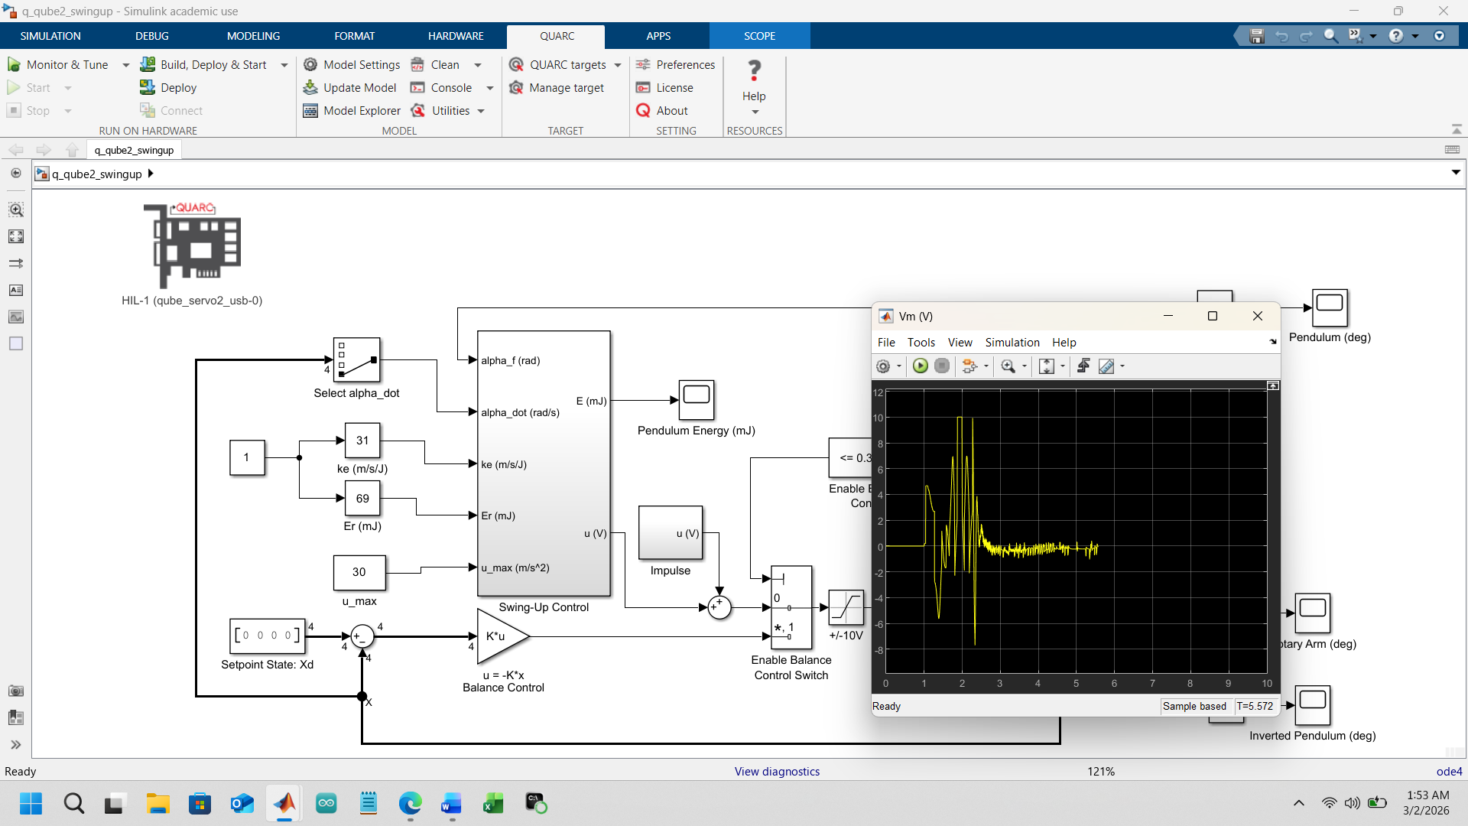
Caption:
Applied motor voltage illustrating control effort during swing‑up and reduced actuation during stabilization.
Explanation:
The motor voltage signal reflects the control input generated by the controller. During swing‑up, Vm exhibits large magnitude and rapid changes, showing aggressive actuation needed to pump energy into the pendulum.
This plot highlights the importance of hardware interfacing and voltage limits, as excessive voltage could saturate the motor or damage the amplifier. Filtering and controller design help prevent sharp discontinuities that would excite unmodeled dynamics.
After stabilization, Vm decreases significantly and becomes smoother, indicating that the PID controller is applying minimal corrective effort to maintain balance. This reduction confirms efficient control and reinforces that the system has reached a stable operating point.
**********************************************************************************

How all Four Stages combine in the final system:
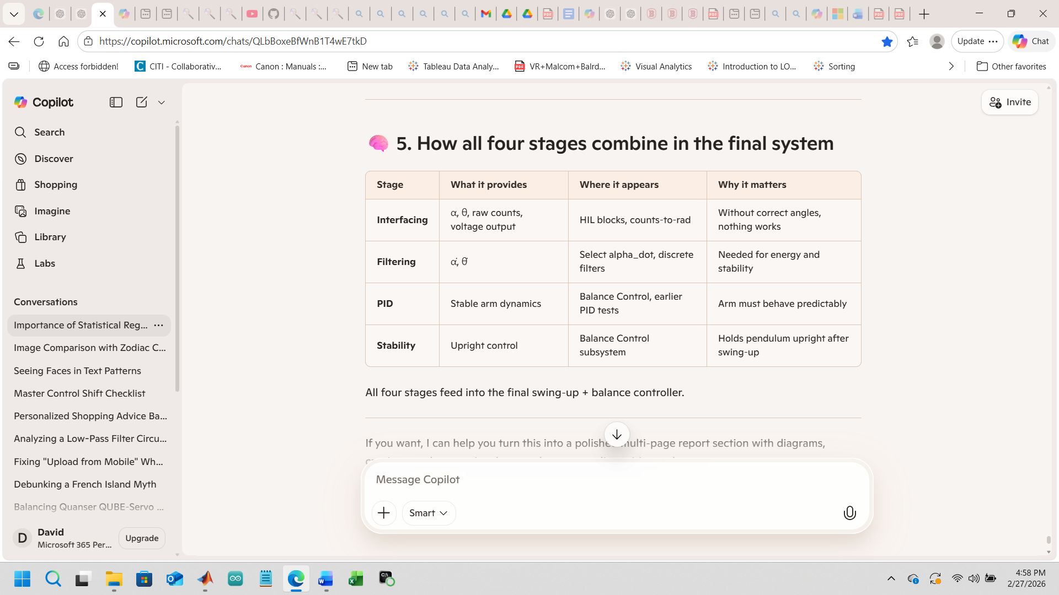

Comparative Discussion (Very Important Section)
Feature | TCLab | QUBE Servo
Speed | Very slow | Very fast
Noise | Minimal | Significant when differentiating
Modeling | Easy | Requires filtering
Dominant Behavior | Thermal first-order | Electromechanical first-order
Control Sensitivity | Low | High
Stability Risk | Low | Moderate
Key takeaway:
Thermal systems emphasize steady-state performance.
Electromechanical systems emphasize transient behavior and stability margins.

Conclusion
The Quanser QUBE-Servo 2 swing-up experiment demonstrated that an energy-based control strategy can reliably drive a nonlinear inverted pendulum system from the stable downward position to the unstable upright equilibrium. Using the derived pendulum energy equation and experimentally tuned controller parameters (e.g., kek_eke​, ErE_rEr​, and umaxu_{max}umax​), the controller successfully injected energy into the system until the pendulum reached the required upright energy level. The plots showed the expected behavior: oscillatory energy growth during swing-up, increasing pendulum angle excursions, and corresponding motor voltage bursts that supplied the required torque. Once the energy threshold was reached, the pendulum repeatedly approached the upright position, demonstrating that the energy controller was functioning correctly and that the hardware dynamics matched the theoretical model. Overall, the experiment confirmed that the energy-shaping control method can effectively regulate the pendulum’s total mechanical energy and produce consistent swing-up behavior on the physical QUBE-Servo 2 platform, validating both the mathematical model and the implemented control strategy.

Appendix

Quanser Qube-Servo-3
“The Quanser Qube-Servo 3 is an integrated, tabletop direct-drive rotary servo platform designed for teaching and research in control systems, featuring a high-quality brushed DC motor, two encoders, and an open-architecture interface. It includes interchangeable modules like an inertia disc and an inverted pendulum, making it ideal for experiments in position, velocity, and balancing control. ”

Key Features of the Quanser Qube (Servo 2/3):
- Integrated Components: Includes a direct-drive brushed DC motor, two optical encoders, and an amplifier.
- Modular Attachments: Supplied with a rotational inertia disk and an inverted pendulum, which connect via magnets for quick, hands-on experiments.
- Open Architecture: Allows users to access internal signals and create custom control algorithms via MATLAB/Simulink or Python.
- Control Experiments: Enables experiments such as position control, velocity control, balancing the pendulum, and swinging up the pendulum.
- Interface: Connects to computers via USB and supports National Instruments myRIO or other microcontrollers.
- Educational Purpose: Designed for undergraduate control systems courses to bridge the gap between theory and practical application.
2) “Key Technical Specifications (QArm):
- Degrees of Freedom: 4
- Maximum Reach: 750 mm
- Joint Ranges:
  - Base: ±170∘
  - Shoulder: ±85∘
  - Elbow: −95∘/+75∘
  - Wrist: ±167.5∘
- Max Speed: ±90∘/𝑠
- Gripper: Tendon-based 2-finger gripper
- Sensors: RGBD camera (included)
- Software Compatibility: QUARC® add-on for MATLAB®/Simulink®, Python, ROS
- Interfaces: USB, PWM, Analog, I²C, SPI, UART
Component Details:
- Motor: DC brush motor
- Encoder: 2 optical encoders with 2048 pulses/revolution resolution
- Structure: Compact, desktop-friendly design with a breakout board for user connections”

3) Power Requirements: “The Quanser QUBE-Servo 3 (and previous QUBE-Servo 2 models) is a compact, direct-drive brushed DC motor system with integrated power electronics, typically requiring a 24V DC power supply.
Here are the detailed power and electrical specifications for the QUBE-Servo:
- Motor Input Voltage: 24V DC nominal.
- Maximum Motor Power/Current: The system includes a PWM amplifier capable of driving the motor with a peak current of 2A and a continuous current of 0.5A.
- Operating Speed (No Load): Approximately 5400 RPM (USB version) or 4050 RPM.
- Amplifier Input: The amplifier receives signals via an RCA connector, with a range of $\pm$10V.
- Data Acquisition (DAQ): The system has integrated DAQ, which is powered through the USB connection or a dedicated power connector depending on the model.
Key Features Affecting Power Use:
- Direct Drive: No gearbox, requiring higher current for higher torque.
- Protection: Includes thermal shutdown of the amplifier and stall detection.
- Encoder Power: The encoders operate on 5V.
Note on QArm: If you are referring to the larger Quanser QArm (not the QUBE base unit), it has different, higher power requirements, though it also uses 24V for its joints.“

4) Applications: ” The Quanser QArm is a 4-degree-of-freedom (DOF) intelligent robotic manipulator designed specifically for academic research, engineering education, and rapid development of robotic applications. It combines hardware, software, and curriculum to teach concepts ranging from basic joint control to advanced artificial intelligence.”

5) Software and Data Acquisition (DAQ) Standards
- Control Software: Fully compatible with industry-standard software: MATLAB®/Simulink® and NI LabVIEW™.
- Data Acquisition (DAQ): The system has an integrated DAQ with 24-bit encoder channels (for quadrature decoding) and 12-bit ADC for current sense feedback, ensuring high-accuracy data measurement.

Matlab Program for Quanser Qube Servo_2

%% Example state inputs (replace with real measurements)
alpha = 0; % pendulum angle (rad)
alpha_dot = 0; % angular velocity (rad/s)
%% Pendulum parameters
mp = 0.095;
g = 9.81;
L = 0.129;
l = 0.085;
Jp_cm = (1/12)*mp*L^2;
Jp = Jp_cm + mp*l^2;
mpgl = mp*g*l;
%% Controller parameters
ke = 32;
Er = mpgl;
u_max = 15;
%% Actuator parameters (NEW SECTION)
mr = 0.095; % effective rotary mass (kg)
r = 0.085; % rotary arm length (m)
Rm = 8.4; % motor resistance (Ohm)
Kt = 0.042; % motor torque constant (Nm/A)
%% Energy calculation
E = 0.5*Jp*alpha_dot^2 + mpgl*(1 - cos(alpha));
%% Energy-based control law (acceleration command)
u = ke*(Er - E)*tanh(alpha_dot)*cos(alpha);
%% Saturation on acceleration
u = max(min(u,u_max),-u_max);
%% Convert acceleration -> torque
tau = mr * r * u;
%% Convert torque -> motor voltage
V = (Rm/Kt) * tau;
%% Final control output
motor_voltage = V;

